

UNIVERSITY OF MUMBAI

A Project Report On

**“Online Railway Reservation System”**

In Partial Fulfillment of the Requirement for Qualifying

B.Sc.(IT), Semester-VI Examination

**Designed & Developed by**

**Priti SANTOSH MAURUA**

APRIL-2019

B.Sc(IT) (2018-2019)



VIDRAVARDHINI’S

A.V College of Arts, K.M College of Commerce, E.S.A College of Science

Vasai Road, Dist. Palghar -401 202



VIDRAVARDHINI’S

A.V College of Arts, K.M College of Commerce, E.S.A College of Science

**DEPARTMENT OF INFORMATION TECHNOLOGY**

**CERTIFICATE**

This is to certify that following students has successfully completed the project titled “**Online Railway Reservation System**”, and duly submitted the project report in partial fulfillment of the “B. Sc. (Information Technology)” degree from the University of Mumbai during the academic year 2018-19.

It is further certified that he has completed all the required phases of the project.

**Team Members Roll-no**

**PRITI SANTOSH MAURYA 29**

________________________ ________________________

Prof. In Charge Internal Examiner

________________________ ________________________

External Examiner Head of Dept.

**ACKNOWLEDGEMENT**

To be honest developing a project ASP.NET with C# for beginners like me was as complicated as finding a pin in the bush. But this brings me immense happiness that eventually this project has successfully accomplished which was almost impossible without the guidance of our project guide.

I would like to thank the entire staff of the Information Technology Department who made this project a reality, especially **Prof. Miss Supriya Mahtre** my project guide for his support in completion of this project.

I take this opportunity to express my gratitude towards our **Prof. Miss Sushma Brahmankar (H.O.D)** sir of our college for their kind co-operation and overwhelming support during my project without which this project would have not been a reality.

We thank the Almighty, above all-whose will sovereign us all especially to **Staff** **Teachers** and **My** **friends** Who help all the regarding to our project.

|  |  |  |
| --- | --- | --- |
| Sr. No. | Contents | Page no. |
| 1 | Organization overview |  |
| 2 | Organization Hierarchy |  |
| 3 | Introduction |  |
| 4 | About Existing System |  |
| 5 | Drawback of Existing System |  |
| 6 | Need for new system |  |
| 7 | Proposed System |  |
| 8 | Features Of New System |  |
| 9 | System Flowchart |  |
| 10 | Feasibility Study |  |
| 11 | UML |  |
| 12 | Menu Tree |  |
| 13 | Program List |  |
| 14 | Database Design |  |
| 15 | Report List |  |
| 16 | Event Table |  |
| 17 | Crud Table |  |
| 18 | Code And Form Layout |  |
| 19 | Gantt Chart |  |
| 20 | Future Scope |  |
| 21 | Bibliography |  |

**OVERVIEW OF ORGANIZATION**

India, majority population of it is contributed by the middle class people. For journey of longer distances though we have airways most of the people use the railways, which is most convenient, affordable means of transport in India.

So keeping this in view, the reservation of railways is a most important task and it must be faster and efficient as the demand is very high. In order to meet this demand, manual reservation is completely ruled out and it requires an efficient program to implement the online reservation.

This program enables us to choose the train even there is no necessary to fill a form at the railway reservation counter, we can directly select from the choices provided for us with train numbers and their origin, departure time, destination & arrival time at that station and the class to travel in. If there is any concession we can also avail it and then program gives us the final output as train ticket with the amount to be paid.

This even simplifies the risks and makes things faster in the mode of railways!!!!

**OVERVIEW OF HIERARCHY**

**Railway Board**  
Indian Railways are owned and managed by Government of India. Ministry of Railways of Government of India is headed by a Minister of Railways assisted by one or two Deputy Ministers. Administration and management of Indian Railways vests with the Railway Board – a top executive body- under the Minister of Railways.  Railway Board exercises powers of Central Government in respect of regulation, construction, maintenance and operation of the Railways.

Railway Board is headed by a Chairman, Financial Commissioner and 5 members each representing a major department of Indian Railways – Member Staff, Member Electrical, Member Mechanical, Member Traffic, Member Engineering.

Financial Commissioner for Railways is vested with full powers of the Government of India to sanction Railway expenditure and is ex-officio Secretary to the Government of India in the Ministry of Railways in financial matters.

Railway Board is assisted by Director General/ Railway Health Services, by Director General/Railway Protection Force & Security and some advisors.

Railway Board establishment is organized as functional directorates, each under an Executive Director who is responsible for the day to day technical and professional business of the Indian Railways as the per the policy guidelines laid out by the Board.

The entire secretariat is supervised by Secretary, Railway Board who is the coordinating officer between different directorates.

Executive Directors are in Senior Administrative Grade(SAG), Directors/Joint Secretaries in Selection Grade, Join Directors/ Dy. Secretaries in Junior Administrative Grade(JAG) and by Directors/ Under Secretaries in Senior Scale.  
In 2003 Government of India through a notification made Railway Board a completely independent body which empowered it to take decision on projects without going through the Railway Ministry. Necessary checks have been made in the form of a body comprising of existing Board members, expenditure secretary and Secretary, Planning Commission.

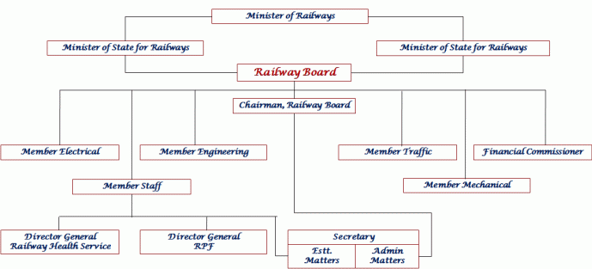

**INTRODUCTION**

Rail transport as one of the most important means of transport, has played an important role in the transport industry in India. With Indian rapid economic development, the railway lines and passengers have been increasing year by year in the country. With such a huge customer base, buying train tickets problem has been very prominent. The electronic commerce could solve the problem of railway ticketing. Introduced a new online ticketing system is not only technological innovation, but also will improve the railway services, to a certain extent, solve the difficult problem of railway ticketing.

Indian Railways is headed by a seven-member [Railway Board](https://en.wikipedia.org/wiki/Railway_Board) whose chairman reports to the [Ministry of Railways](https://en.wikipedia.org/wiki/Ministry_of_Railways_(India)). IR is divided into 17 zones, headed by general managers who report to the Railway Board. The zones are further subdivided into 68 operating [divisions](https://en.wikipedia.org/wiki/Zones_and_divisions_of_Indian_Railways), headed by divisional railway managers (DRM). The divisional officers of the engineering, mechanical, electrical, signal and telecommunication, stores, accounts, personnel, operating, commercial, security and safety branches report to their respective DRMs and are tasked with the operation and maintenance of assets. Station masters control individual stations and train movements through their stations' territory. In addition, there are a number of Production Units, Training Establishments, Public Sector Enterprises and other Offices working under the control of Railway Board.

**ABOUT RAILWAY RESERVATION SYSTEM**

This project introduces Railway Reservation System. Railway ticket booking system software projects main aim is to provide a secure and easy way to book train tickets. This project is developed in C# language. This ONLINE RAILWAY RESERVATION SYSTEM should be able to manage all the reservation related functions.

The purpose of Railway Reservation System is a software application which provides the train timing details, reservation, billing and cancellation.

Using these system Ticket Counter person can perform operations like finding out the train timings and to know information about PNR status, seats availability and costs of each ticket, etc.

 if you book ticket which is not confirmed then you can keep checking its status on **PNR ENQUIRY**. It is get updated if passengers cancel their tickets. Since tickets are booked in advance and passengers may change their travel plans so many tickets are cancelled. Although there is a cancellation charge as well.

In some countries, like Italy, and some [local railways](https://en.wikipedia.org/wiki/S-bahn) in Germany, conductors are not used. Instead passengers are expected to validate tickets in a special stamping machine before entering the train. A system of coupons that are validated with a special machine exists on the [Mumbai Suburban Railway](https://en.wikipedia.org/wiki/Mumbai_Suburban_Railway) where combinations of coupons of different denominations are used to get the corresponding ticket value. There may or may not be a conductor later on double-checking that correct tickets are actually held. Yet further systems are possible, for example in Japan, the London Underground and in local traffic in Stockholm, the platforms are physically blocked, forcing the acquisition of a ticket before entering the platform.

**DRAWBACK OF RAILWAY RESERVATION SYSTEM**

This deprives the non-e-citizens of their right to equal access. The non-e-citizens are (usually) already illiterate, ignorant, young, aged or disabled. They are vulnerable sections of society. Having access to e-services will be crucial to productivity and earning capacity much more than it is for e-citizens.

**Impact of digital divide**

Take for example the millions of Indians who flock to the Indian Railway Reservation counters for their travel needs. A e-citizens despite a slow internet access can complete the ticket booking process in less than 5 minutes - from login to e-ticket from the comforts of their homes.

Whereas a non-e-citizen will have to

* Get ready
* Travel to ticket counter
* Fill up form (if illiterate by someone else)
* Stand in queue
* Buy ticket with cash
* Go back home/work

This process will be anywhere between 2–3 hours. For a person, who is already poor, this will be expensive option. It takes away 20% of daily wages. Something they cannot afford to do with their hand-to-mouth existence. There is no use of a facility for the poor without the having the necessary infrastructure at affordable prices. This will be counter-productive to the objective of serving the needy.

**Digital reach**

The rise of e-Services while being progressive needs to compassionately address issues of the non-e-citizens.

This means that 93% of Indians don’t have access to internet and are not digitally empowered citizens - that is about a billion plus people.

**NEED FOR NEW RAILWAY SYSTEM**

* No extra charges will be taken from passenger or any refund shall be provided for difference of fare.
* Passengers once provided alternate accommodation in alternate train will be treated as normal passengers in alternate train and will be eligible for upgradation.
* Wait-listed passengers of original train will not be allowed to board the original train if allotted alternate accommodation.
* The latest move is aimed at optimizing utilization of seats across all trains thereby increasing earnings and reducing refunds on waitlisted tickets.
* A computer reservation system or central reservation system (CRS) is a computerized system used to store and retrieve information and conduct transactions related to air travel, hotels, car rental, or other activities.

**Description of Proposed System:**

* Currently System is computerized.
* Currently maintain records are not automated.
* It is easy to generate tickets.
* Currently System provide more data.
* All types information about trains available here.

**Advantages of Proposed System:**

**GUI:** It provides better GUI.

**Search:** In this we can search the trains.

**Increase Work Speed:** Due to Automation of system work speed will increase and it is time saving.

**Time Saving:** It takes less time.

**Facility:** It is very easy to access and retain the information about trains, bills, etc.

**Flexibility:** The database is flexible and can be easily modified when some changes in the system require.

**Security:** The system informs the administrator every login and logout any authorized person is given access it keeps all records safely or save from any accident like burning and water damage.

**Accuracy:** Computerized system will be accurate enough to provide minimum errors to perform any number of calculation and also this provide to remove the problem which may present in the system.

**User-Friendly:** The system is user friendly software will create a flexible and can for table environment and it leads to make everything more and beneficial.

**Reduce-Error:** Due to computerized there is less possibility of error.

**Loss of Data:** Tampering or loss of data is avoided.

**Economical:** Due to minimal error and work delay proposed system can be economically helpful.

|  |  |  |  |  |  |  |
| --- | --- | --- | --- | --- | --- | --- |
| Sr. No. | Phase | Duration | Start Date | Finish Date | Actual Finish Date | Sign |
| I | Planning | 19 | 23-Oct-17 | 10-Nov-17 | 10-Nov-17 |  |
| 1.1 | Defining Problem | 10 | 23-Oct-17 | 01-Nov-17 | 01-Nov-17 |  |
| 1.2 | Confirm Project Feasibility | 4 | 02-Nov-17 | 05-Nov-17 | 05-Nov-17 |  |
| 1.3 | Project Schedule | 3 | 06-Nov-17 | 08-Nov-17 | 08-Nov-17 |  |
| 1.4 | Staffing Project | 1 | 09-Nov-17 | 09-Nov-17 | 09-Nov-17 |  |
| 1.5 | Launching Project | 1 | 10-Nov-17 | 10-Nov-17 | 10-Nov-17 |  |
| II | Analysis Phase | 21 | 11-Nov-17 | 01-Dec-17 | 01-Dec-17 |  |
| 2.1 | Gathering Information | 11 | 11-Nov-17 | 21-Nov-17 | 21-Nov-17 |  |
| 2.2 | Defining System Requirement | 6 | 22-Nov-17 | 27-Nov-17 | 27-Nov-17 |  |
| 2.3 | Prioritize Requirements | 2 | 28-Nov-17 | 29-Nov-17 | 29-Nov-17 |  |
| 2.4 | Generate and evaluate alternatives | 1 | 11-Nov-17 | 30-Nov-17 | 30-Nov-17 |  |
| 2.5 | Review recommendation | 1 | 01-Dec-17 | 01-Dec-17 | 01-Dec-17 |  |
| III | Design | 42 | 02-Dec-17 | 12-Jan-18 | 12-Jan-18 |  |
| 3.1 | Design user interface | 22 | 02-Dec-17 | 23-Dec-17 | 03-Jan-17 |  |
| 3.2 | Design Application Architecture | 10 | 24-Dec-17 | 02-Jan-18 | 02-Jan-18 |  |
| 3.3 | Design and interact Database | 8 | 03-Jan-18 | 20-Mar-18 | 25-Mar-18 |  |
| 3.4 | Design and Integrate System | 2 | 11-Jan-18 | 12-Jan-18 | 25-Feb-18 |  |
| IV | Implementation Phase | 47 | 13-Jan-18 | 28-Feb-18 | 28-Feb-18 |  |
| 4.1 | Construct the software component | 28 | 13- Feb -18 | 09- Mar -18 | 09-Mar-18 |  |
| 4.2 | Verify and test components | 12 | 10- Mar -18 | 21- Mar -18 | 21- Mar-18 |  |
| 4.3 | Training and Documenting | 4 | 21- Mar -18 | 25- Mar -18 | 25- Mar-18 |  |

**Overview of Front End**

A Visual Studio Web application is built around ASP.NET. ASP.NET is a platform — including design-time objects and controls and a run-time execution context — for developing and running applications on a Web server.

ASP.NET in turn is part of the .NET Framework, so that it provides access to all of the features of that framework. For example, you can create ASP.NET Web applications using any .NET programming language (Visual Basic, C#, Managed Extensions for C++, and many others) and .NET debugging facilities. You access data using ADO.NET. Similarly, you can access operating system services using .NET Framework classes, and so on.

ASP.NET Web applications run on a Web server configured with Microsoft Internet Information Services (IIS). However, you do not need to work directly with IIS. You can program IIS facilities using ASP.NET classes, and Visual Studio handles file management tasks such as creating IIS applications when needed and providing ways for you to deploy your Web applications to IIS.

The advantage of using Visual Studio is that it provides tools that make application development much faster, easier, and more reliable. These tools include:

Visual designers for Web pages with drag-and-drop controls and code (HTML) views with syntax checking.

Code-aware editors that include statement completion, syntax checking, and other IntelliSense features.

Integrated compilation and debugging.

Project management facilities for creating and managing application files, including deployment to local or remote servers.

**1.4.2 Overview of Back End**

Microsoft SQL Server 2008 Express is a database platform that is based on Microsoft SQL Server. SQL Server Express makes it easy to develop data-driven applications that are rich in capability, offer enhanced storage security, and are fast to deploy.

SQL Server 2008 Express with Advanced Services is an edition of SQL Server Express that includes a new graphical management tool, features for reporting, and advanced text-based search capabilities.

SQL Server 2008 Express with Tools is an edition of SQL Server Express that includes basic graphical management tools.

All editions of SQL Server Express are free downloads that can be redistributed subject to agreement. Each edition can function both as the client database and as a basic server database. Any edition of SQL Server Express is an ideal choice for independent software vendors (ISVs), server users, non-professional developers, Web developers, Web site hosts, and hobbyists who are building client applications. If you need more advanced database features, you can upgrade SQL Server Express to more sophisticated versions of SQL Server.

**SYSTEM FLOWCHART**

The data flow diagram is a graphical representation that depicts information flow and the transforms that are applied as data moves from input to output. The DFD may be used to represent a system or software at any level of abstraction. In fact DFD may be partitioned into levels that represent increasing information flow and functional detail.

The level 0 DFD or a context model represents the entire software element as a single bubble with input and output data indicated by incoming and outgoing arrows, respectively.

**Zero Level DFD**

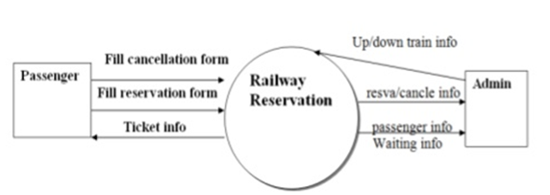

**1 Level DFD**

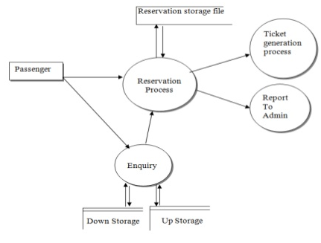

**2 Level DFD**

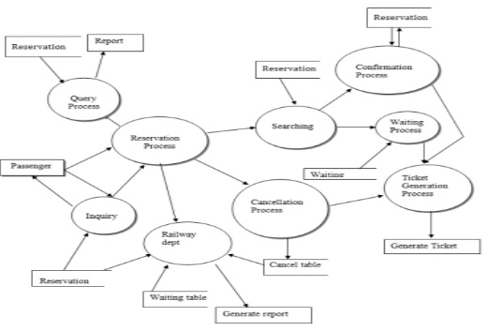

**2 System Analysis:**

**2.1 Feasibility Study:**

Feasibility study is the process of determination of whether or not a project is worth doing. Feasibility studies are undertaken within tight time constraints and normally culminate in a written and oral feasibility report. The contents and recommendations of this feasibility study helped us as a sound basis for deciding how to precede the project. It helped in taking decisions such as which software to use, hardware combinations, etc.

The following is the process diagram for feasibility analysis. In the diagram, the feasibility analysis starts with the user set of requirements. With this, the existing system is also observed. The next step is to check for the deficiencies in the existing system. By evaluating the above points a fresh idea is conceived to define and quantify the required goals. The user consent is very important for the new plan. Along with, for implementing the new system, the ability of the organization is also checked. Besides that, a set of alternatives and their feasibility is also considered in case of any failure in the proposed system. Thus, feasibility study is an important part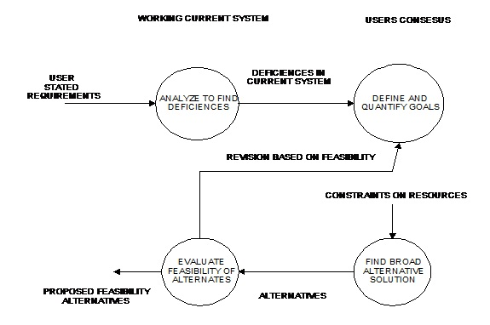 in software development.

The different type of feasibility are as follow:

* Technical feasibility.
* Operation feasibility.

**2.1.1 Technical Feasibility :**

This project is feasible on technical remarks also, as the proposed system is more beneficiary in terms of having a sound proof system with new technical components installed on the system. The proposed system can run on any machines supporting Windows and Internet services and works on the best software and hardware that had been used while designing the system so it would be feasible in all technical terms of feasibility. The necessary software required for development of the system is

* ASP.NET with C#.
* Microsoft SQL Server.

There is requirement for mentioned software and an expertise for handling system. Thus in the presence of required hardware, software the proposed system is technically feasible.

Operation feasibility is a measure of how people feel about the system. Operational Feasibility criteria measure the urgency of the problem or the acceptability of a solution. Operational Feasibility is dependent upon determining human resources for the project. It refers to projecting whether the system will operate and be used once it is installed.

1. If the ultimate users are comfortable with the present system and they see no problem with its continuance, then resistance to its operation will be zero.

Behaviorally also the proposed system is feasible. A particular application may be technically and but may fail to produce the forecasted benefits, because the company is not able to get it to work. For the system, it is not necessary that the user must be a computer expert, but any computer operator given a little bit of knowledge and training can easily operate

**System Design**

**Software Requirement Specification**

**Introduction**

Software requirement specification abbreviated as SRS is a means of translating the idea of files into a formal document. The main features of SRS include:

* Establishing the basis for an agreement between the client and the developer.
* Producing a reference for validation of the final product. SRS assist clients in determining if the software meets the requirements.

Mainly there are six requirements which an SRS must satisfy.

(a) It should specify the external behavior .

(b) It should specify the constraints.

(c) It should be easy to change.

(d) It should be a reference tool.

(e) It should record throughout the lifecycle.

(f) It should have the capacity of expectation of an undesired event.

Usually we come across four types of requirement specification

* User Interface Requirements :
* **Microsoft Visual Studio 2010**
* **Browser Google Chrome**

The user of the proposed system requires that the developed software should be user friendly, have security access, and ensure the privacy of the administrator and produce results in timely manner. The users are not frequently exposed to the mail system, so the system interface to the user must be simple and understandable. The web pages must be user-friendly and must be in an easy-to-use style. The user must be able to easily switch among various I/O screens. The product is well designed so that it can be used easily by the users who are novices to the system. The user interface should be as interactive as possible. A user friendly interface must be provided so that the user can easily interact with the system and comprehend things in a quicker and easier way.

* Database Requirements :
* **SQL Server 2008**

The database should be designed in such a way that it enhances the efficient searching, reservation and manipulation of all the information associated. For instance all general information regarding an item attribute should be stored in a particular table. The database should be organized in such a way that it helps in searching and reserving various essential summaries needed for users.

* Functional Requirements:

The various functional requirements of the system can be summarized as :

* A home page that is user friendly and ambiguous.
* It is easy to sign in a user in his page.
* User can easily send mails to different uses in an office.
* User can easily view the inward mails and local mails.
* User can easily remove the mails from his inbox.
* Attractions.
* SPECIALITIES.
* Non-Functional Requirements:

Non-functional requirements define the system properties and constraints that arise through user needs, because of the budgeted constraints or organizational policies, or because of the need for interoperability with other software or due to the external factors such as safety regulations privacy registrations and so on.

**UML Diagrams**

**Use Case Diagram**

**Admin Subsystem:**

1. Admin creates the new account and logins into the account.
2. Admin can add train details.
3. Admin can update train details.
4. Admin can add Fare details.
5. Admin can update Fare details.
6. Admin can delete the train details.

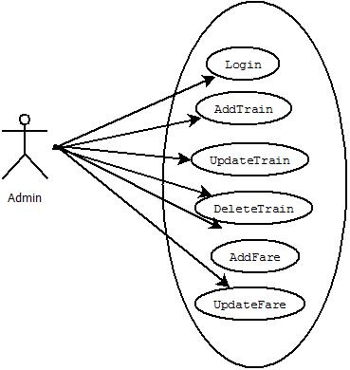

**Customer Subsystem:**

1. Customer creates the new account and logins into the account.
2. Customer can search the train.
3. Customer can check the availability trains.
4. Customer can book the tickets.
5. Customer can add the details.
6. Customer can edit details.
7. Customer can check PNR Status.
8. Customer can pay the bill of tickets.
9. Customer can print the tickets.

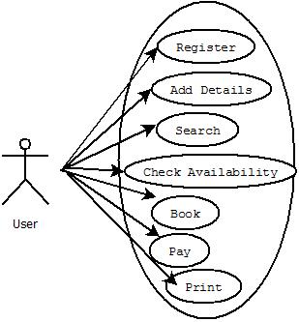

**USE CASE :**



**Activity Diagram of Railway Reservation System:**

**Entity Relationship Diagram**

* Entity relationship diagram can express overall logical structure of database logically.
* ER Diagrams are simple and clear.
* ER Diagrams entities and tables and their relationship with one another.

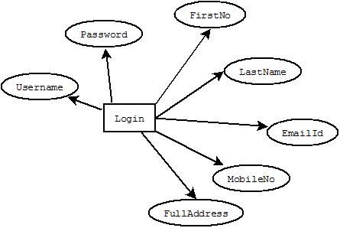

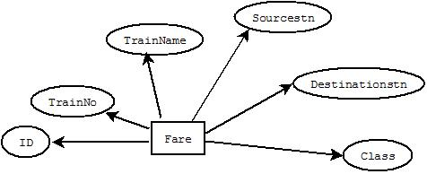

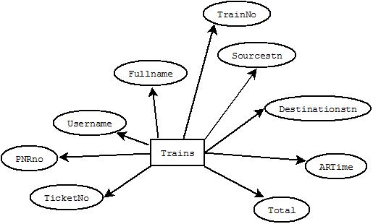

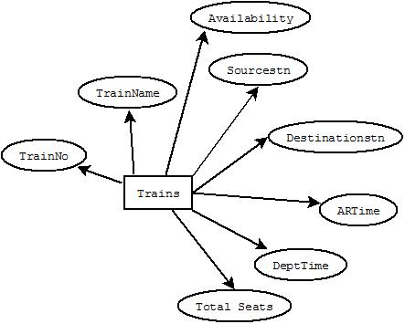

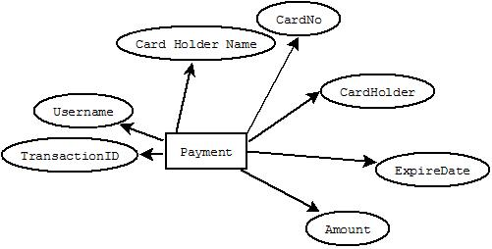

**Class Diagram**

**Sequence diagram:**

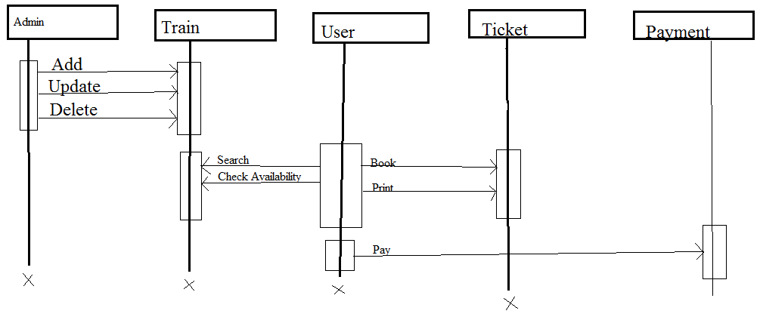

**Menu Tree**

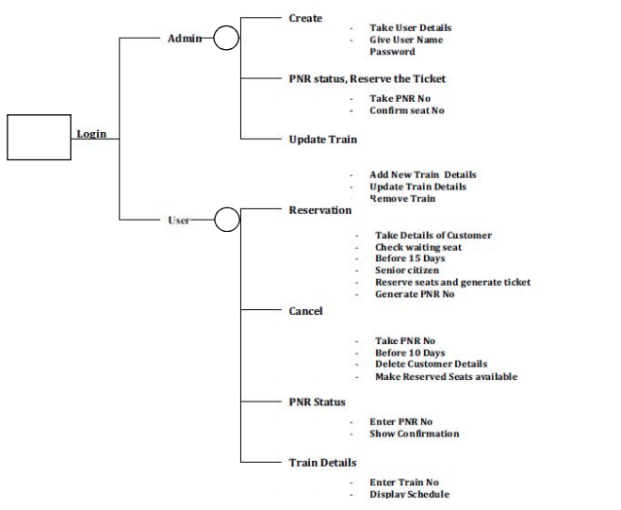

**Program List :**

* **Welcome Page**
* **Home Page**
* **Signup**
* **Add Train**
* **Add Fare**
* **Manage Train**
* **Manage Fare**
* **Payment**
* **Search Train**
* **Book Ticket**
* **Cancel Ticket**
* **Print Ticket**
* **PNR Status**
* **Forgot Password**

**Database Tables:**

**Login Table:**

|  |  |
| --- | --- |
| **Column Name** | **Datatype** |
| Id | Int |
| Username | varchar(200) |
| Password | Varchar(200) |
| Firstname | Varchar(200) |
| Lastname | Varchar(200) |
| Email | Varchar(150) |
| MobileNo | Varchar(20) |
| Fulladdress | Varchar(250) |

**Fare Table:**

|  |  |
| --- | --- |
| **Column Name** | **Datatype** |
| ID | Int |
| TrainNo | Int |
| TrainName | nvarchar(50) |
| Sourcestn | nvarchar(50) |
| Destinationstn | nvarchar(50) |
| General | Int |
| Sleeper | Int |
| AC I | Int |
| AC II | Int |
| AC III | Int |

**Payment Table:**

|  |  |
| --- | --- |
| **Column Name** | **Datatype** |
| TransactionID | Int |
| UserName | nvarchar(50) |
| CardHolderName | nvarchar(50) |
| CardNo | Nvarchar(25) |
| CardHolder | nchar(6) |
| ExpireDate | Date |
| Amount | Int |

**Trains Table:**

|  |  |
| --- | --- |
| **Column Name** | **Datatype** |
| TrainNo | Int |
| TrainName | varchar(250) |
| Sourcestn | varchar(200) |
| Destinationstn | varchar(200) |
| Arrtime | varchar(100) |
| Depttime | varchar(100) |
| Totalseats | Int |
| availableseats | Int |

**Ticket Table:**

|  |  |
| --- | --- |
| **Column Name** | **Datatype** |
| TicketNo | nvarchar(15) |
| PNRno | nvarchar(50) |
| UserName | nvarchar(200) |
| FullName | Int |
| TrainNo | nvarchar(50) |
| TrainName | nvarchar(50) |
| Sourcestn | nvarchar(50) |
| Destinationstn | nvarchar(50) |
| ARtime | nvarchar(50) |
| Depttime | nvarchar(50) |
| JDate | Date |
| ClassType | nvarchar(25) |
| NoOfPersons | Int |
| Total | Int |

**Event Table :**

**Limited Decision :**

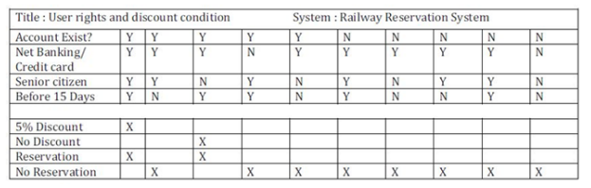

**Mixed Decision Table :**

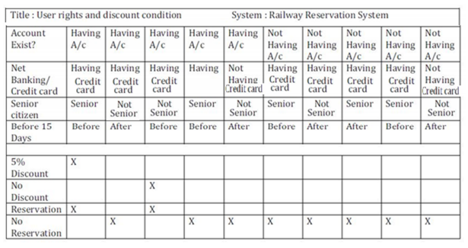

**Extended Table :**

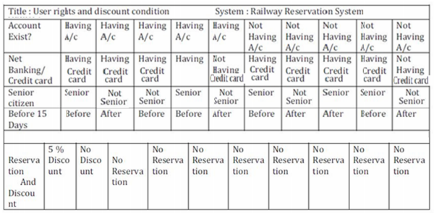

**GANTT Chart :**

|  |  |  |  |  |  |  |
| --- | --- | --- | --- | --- | --- | --- |
| **Month**  **Process** | **NOV**  **2017** | | **DEC**  **2017** | **JAN**  **2018** | **FEB**  **2018** | **MAR**  **2018** |
| **Preliminary**  **Investigation** |  |  | |  |  |  |
| **System**  **Analysis** |  |  | |  |  |  |
| **System Design** |  |  | |  |  |  |
| **System**  **Coding** |  | **8** | |  |  |  |
| **Maintenance & Evaluation** |  |  | |  |  |  |

**- Planned Date**

**- Actual Date**

**CODE AND FORM LAYOUT**

**Home page**

**Default.aspx**

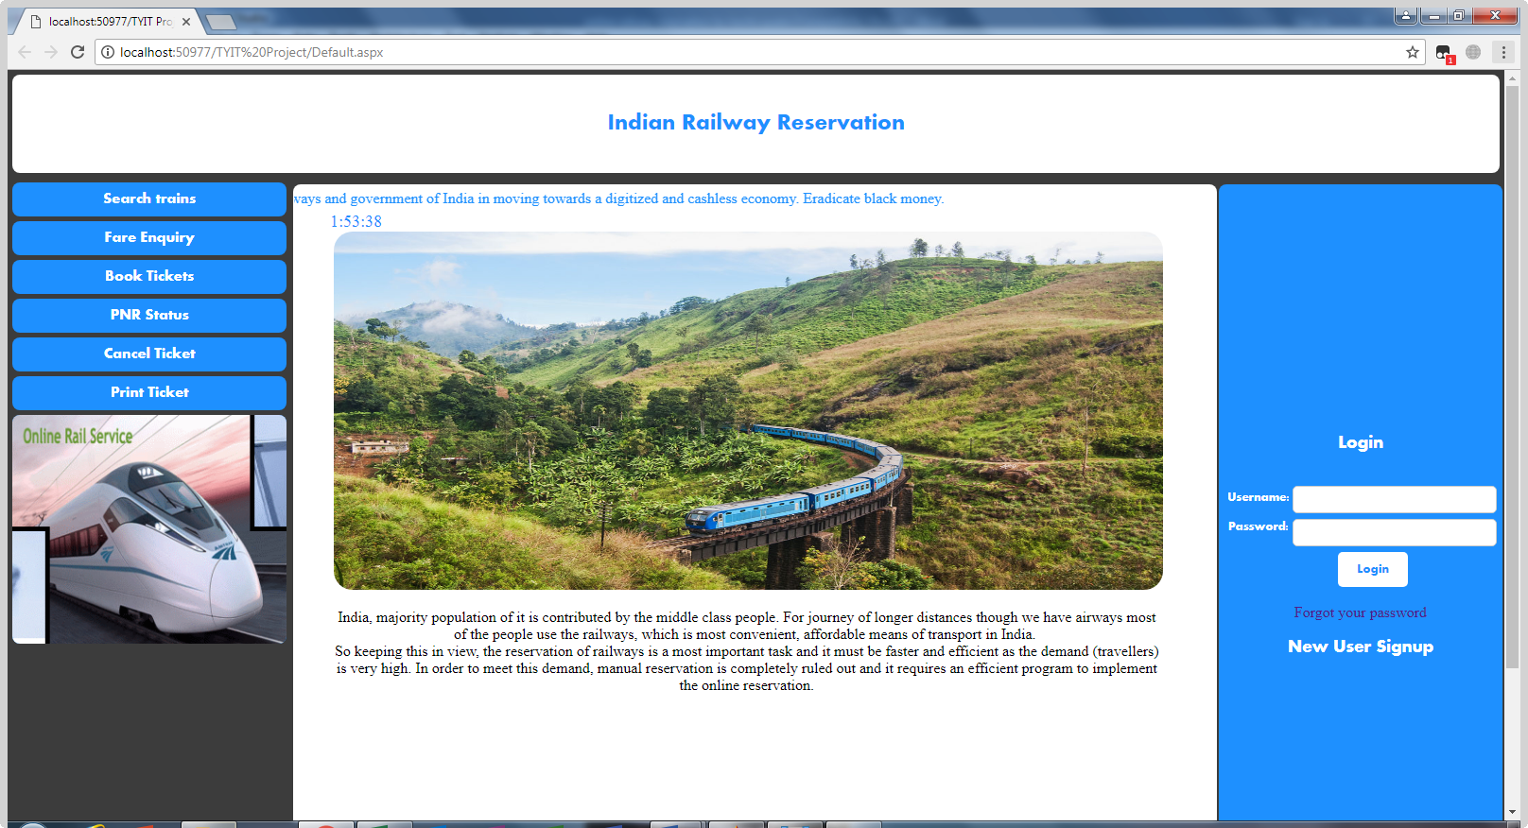**+**

**Code:**

<%@ Page Title="" Language="C#" MasterPageFile="~/MasterPage.master" AutoEventWireup="true" CodeFile="Default.aspx.cs" Inherits="_Default" %>

<asp:Content ID="Content1" ContentPlaceHolderID="head" Runat="Server">

</asp:Content>

<asp:Content ID="Content2" ContentPlaceHolderID="MainContentPlaceHolder" Runat="Server">

<div class="main" >

<marquee>

Please help Indian railways and government of India in moving towards a digitized and cashless economy. Eradicate black money.

</marquee>

<br />

<span id="txt" dir="rtl"></span>

<script>

window.onload = function () { getTime(); }

function getTime() {

var today = new Date();

var h = today.getHours();

var m = today.getMinutes();

var s = today.getSeconds();

// add a zero in front of numbers<10

m = checkTime(m);

s = checkTime(s);

document.getElementById('txt').innerHTML = h + ":" + m + ":" + s;

setTimeout(function () { getTime() }, 1000);

}

//setInterval("getTime()",1000);//another way

function checkTime(i) {

if (i < 10) {

i = "0" + i;

}

return i;

}

</script>

<br />

<img alt="Welcome To Railway Reservation" src="images/trainwel.jpg" />

<br />

<div style="width: 90%; margin-left:40px;" align="center" >

<p>India, majority population of it is contributed by the middle class people. For journey of longer distances though we have airways most of the people use the railways, which is most convenient, affordable means of transport in India.

<br />So keeping this in view, the reservation of railways is a most important task and it must be faster and efficient as the demand (travellers) is very high. In order to meet this demand, manual reservation is completely ruled out and it requires an efficient program to implement the online reservation.

</p>

</div>

</div>

</asp:Content>

<asp:Content ID="Content3" ContentPlaceHolderID="ContentPlaceHolder2" Runat="Server">

<style>

h3

{

color:white;

font-family:Aharoni;

}

h3 a

{

color:White;

font-family:Aharoni;

}

a:link

{

text-decoration:none;

}

input[type=text]

{

width: 100%;

padding: 6px;

border: 1px solid #ccc;

border-radius: 5px;

box-sizing: border-box;

}

input[type=password]

{

width: 100%;

padding: 6px;

border: 1px solid #ccc;

border-radius: 5px;

box-sizing: border-box;

}

label

{

color:white;

font-family:Aharoni;

padding: 6px 0 6px 0;

display: inline-block;

}

.row

{

padding:5px;

}

.col25

{

float:left;

width:25%;

margin-top:6px;

}

.col75

{

float:right;

width:75%;

margin-top:6px;

}

input[type=submit]

{

background-color:white;

color:DodgerBlue;

padding: 12px 20px;

margin-top:6px;

font-family:Aharoni;

border: none;

border-radius: 5px;

cursor: pointer;

margin-left: 30px;

}

input[type=submit]:hover

{

background-color: DodgerBlue;

color:white;

}

.container

{

height:100%;

}

p.MsoNormal

{margin-top:0in;

margin-right:0in;

margin-bottom:10.0pt;

margin-left:0in;

line-height:115%;

font-size:11.0pt;

font-family:"Calibri",sans-serif;

}

</style>

<div class="container">

<h3><label id="head" runat="server">Login</label></h3>

<form id="form1" runat="server">

<label ID="lblerror" runat="server" Visible="false" style="color: Red; background-color:rgb(255, 171, 152);

color:Red;

padding:10px;

padding-right:25px;

padding-left:25px;

border:2px;

border-radius:5px;

BorderStyle=Solid;

BorderColor=Red;">Invalid Username or Password</label>

<div class="row">

<div class="col25">

<label style="font-size: small">Username:</label>

</div>

<div class="col75">

<asp:TextBox ID="TextBox1" runat="server"></asp:TextBox>

</div>

</div>

<div class="row">

<div class="col25">

<label style="font-size: small">Password:</label>

</div>

<div class="col75">

<asp:TextBox ID="TextBox2" runat="server" TextMode="Password"></asp:TextBox>

</div>

</div>

<asp:Button ID="login" runat="server" Text="Login" font-family="Aharoni"

onclick="Button1_Click" />

<br /><br />

<a href=# onclick="window.open('forgetpass.aspx','width=500,height=50,top=300,left=500,fullscreen=no,resizable=0');">Forgot your password</a>

<h3>New User <a href="Signup.aspx">Signup</a></h3>

</form>

</div>

</asp:Content>

**Signup.aspx**

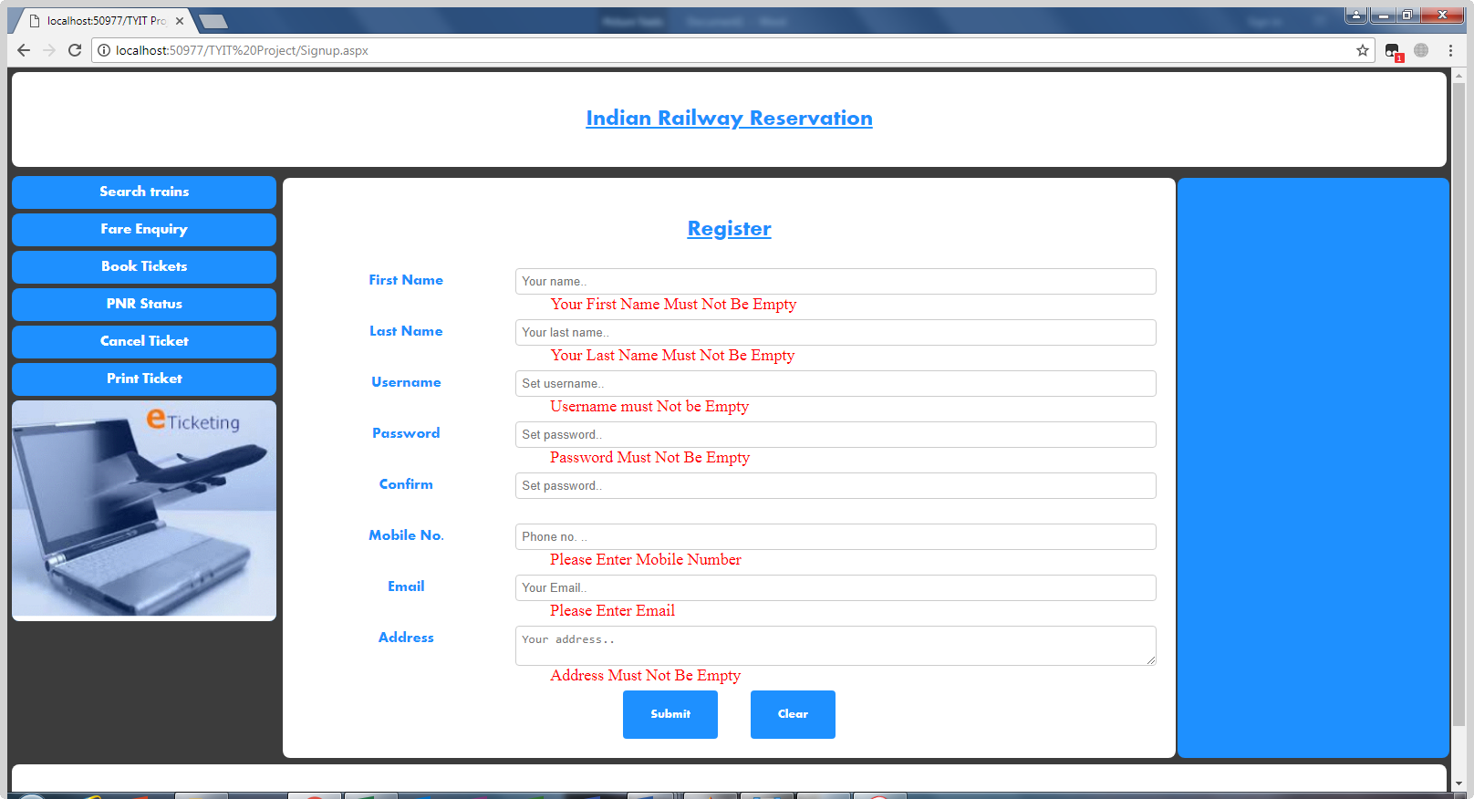

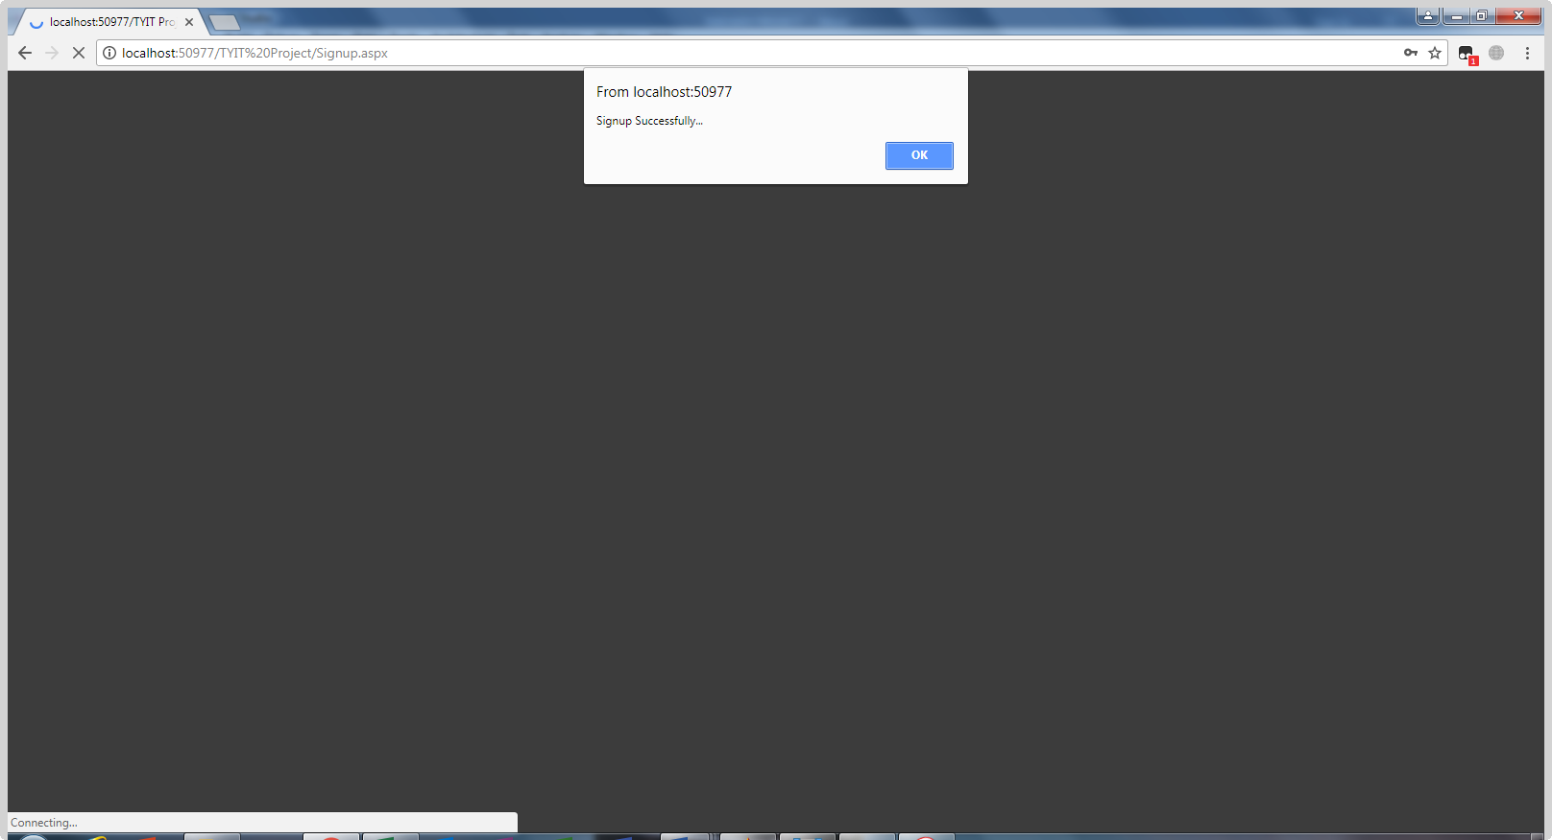

<%@ Page Title="" Language="C#" MasterPageFile="~/MasterPage.master" AutoEventWireup="true" CodeFile="Signup.aspx.cs" Inherits="Signup" %>

<asp:Content ID="Content1" ContentPlaceHolderID="head" Runat="Server">

</asp:Content>

<asp:Content ID="Content2" ContentPlaceHolderID="MainContentPlaceHolder" Runat="Server">

<style>

* {

box-sizing: border-box;

}

input[type=text], select, textarea{

width: 100%;

padding: 6px;

border: 1px solid #ccc;

border-radius: 4px;

box-sizing: border-box;

resize: vertical;

}

.phone

{

width: 100%;

padding: 6px;

border: 1px solid #ccc;

border-radius: 4px;

box-sizing: border-box;

resize: vertical;

}

input[type=password], select, textarea{

width: 100%;

padding: 6px;

border: 1px solid #ccc;

border-radius: 4px;

box-sizing: border-box;

resize: vertical;

}

input[type=email], select, textarea{

width: 100%;

padding: 6px;

border: 1px solid #ccc;

border-radius: 4px;

box-sizing: border-box;

resize: vertical;

}

label {

padding: 6px 6px 6px 0;

color:DodgerBlue;

font-family:Aharoni;

display: inline-block;

}

input[type=submit] {

background-color: DodgerBlue;

color: white;

font-family:Aharoni;

margin-top:6px;

padding: 20px 30px;

border: none;

border-radius: 4px;

cursor: pointer;

align:center;

}

input[type=submit]:hover {

background-color:white;

color:DodgerBlue;

}

.container {

border-radius: 5px;

background-color:white;

padding: 20px;

}

.col-25 {

float: left;

width: 25%;

margin-top: 6px;

}

.col-75 {

float: left;

width: 75%;

margin-top: 6px;

}

h3

{

color:Dodgerblue;

}

.signup

{

border-radius: 5px;

background-color:white;

padding: 20px;

}

</style>

<div class="signup">

<form id="form1" runat="server">

<h3 style=" font-size: x-large; font-family: Aharoni; text-decoration: underline">Register</h3>

<div class="row">

<div class="col-25">

<label for="fname">First Name</label>

</div>

<div class="col-75">

<asp:TextBox ID="TextBox1" runat="server" placeholder="Your name.."></asp:TextBox>

<asp:RequiredFieldValidator runat="server" ErrorMessage="Your First Name Must Not Be Empty"

ForeColor="Red" ID="RequiredFieldValidator1"

ControlToValidate="TextBox1"></asp:RequiredFieldValidator>

</div>

</div>

<div class="row">

<div class="col-25">

<label for="fname">Last Name</label>

</div>

<div class="col-75">

<asp:TextBox ID="TextBox2" runat="server" placeholder="Your last name.."></asp:TextBox>

<asp:RequiredFieldValidator ID="RequiredFieldValidator2" runat="server"

ErrorMessage="Your Last Name Must Not Be Empty" ForeColor="red"

ControlToValidate="TextBox2"></asp:RequiredFieldValidator>

</div>

</div>

<div class="row">

<div class="col-25">

<label for="fname">Username</label>

</div>

<div class="col-75">

<asp:TextBox ID="TextBox3" runat="server" placeholder="Set username.."></asp:TextBox>

<asp:RequiredFieldValidator ID="RequiredFieldValidator3" runat="server"

ErrorMessage="Username must Not be Empty" ForeColor="red"

ControlToValidate="TextBox3"></asp:RequiredFieldValidator>

</div>

</div>

<div class="row">

<div class="col-25">

<label>Password</label>

</div>

<div class="col-75">

<asp:TextBox ID="TextBox4" runat="server" placeholder="Set password.." TextMode="Password"></asp:TextBox>

<asp:RequiredFieldValidator ID="RequiredFieldValidator4" runat="server"

ErrorMessage="Password Must Not Be Empty" ForeColor="red"

ControlToValidate="TextBox4"></asp:RequiredFieldValidator>

</div>

</div>

<br />

<div class="row">

<div class="col-25">

<label>Confirm</label>

</div>

<div class="col-75">

<asp:TextBox ID="TextBox8" runat="server" placeholder="Set password.." TextMode="Password"></asp:TextBox>

<asp:CompareValidator ID="CompareValidator1" runat="server"

ControlToCompare="TextBox4" ControlToValidate="TextBox8"

ErrorMessage="Password Do Not Match" ForeColor="Red"></asp:CompareValidator>

</div>

</div>

<br />

<div class="row">

<div class="col-25">

<label>Mobile No.</label>

</div>

<div class="col-75">

<asp:TextBox ID="TextBox7" runat="server" placeholder="Phone no. .."

class="phone" TextMode="Number"></asp:TextBox>

<asp:RequiredFieldValidator ID="RequiredFieldValidator7" runat="server"

ErrorMessage="Please Enter Mobile Number " ForeColor="red"

ControlToValidate="TextBox3"></asp:RequiredFieldValidator>

</div>

</div>

<br />

<div class="row">

<div class="col-25">

<label>Email</label>

</div>

<div class="col-75">

<asp:TextBox ID="TextBox5" runat="server" placeholder="Your Email.."

TextMode="Email" ></asp:TextBox>

<asp:RequiredFieldValidator ID="RequiredFieldValidator5" runat="server"

ErrorMessage="Please Enter Email" ForeColor="red"

ControlToValidate="TextBox5"></asp:RequiredFieldValidator>

</div>

</div>

<br />

<div class="row">

<div class="col-25">

<label>Address</label>

</div>

<div class="col-75">

<asp:TextBox ID="TextBox6" runat="server" placeholder="Your address.." TextMode="MultiLine"></asp:TextBox>

<asp:RequiredFieldValidator ID="RequiredFieldValidator6" runat="server"

ErrorMessage="Address Must Not Be Empty" ForeColor="red"

ControlToValidate="TextBox6"></asp:RequiredFieldValidator>

</div>

</div>

<br />

<div class="row">

<asp:Button ID="submit" runat="server" Text="Submit" onclick="submit_Click" />

&nbsp;&nbsp;&nbsp;&nbsp;&nbsp;&nbsp;&nbsp;

<asp:Button ID="clear" runat="server" Text="Clear" onclick="clear_Click" />

</div>

</form>

</div>

</asp:Content>

<asp:Content ID="Content3" ContentPlaceHolderID="ContentPlaceHolder2" Runat="Server">

<p>

&nbsp;</p>

</asp:Content>

**User login Error**

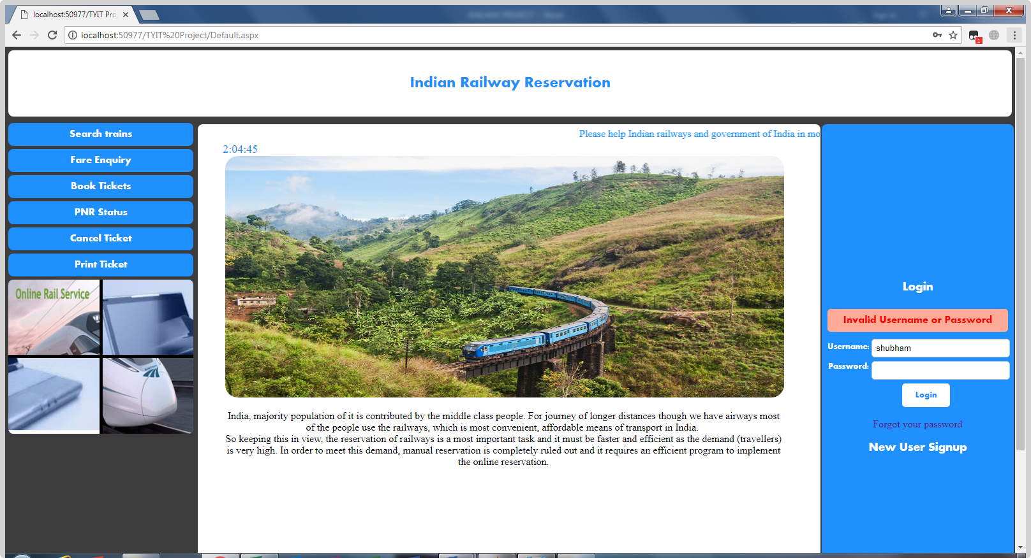

**Admin login**

1. **AddTrain.aspx**

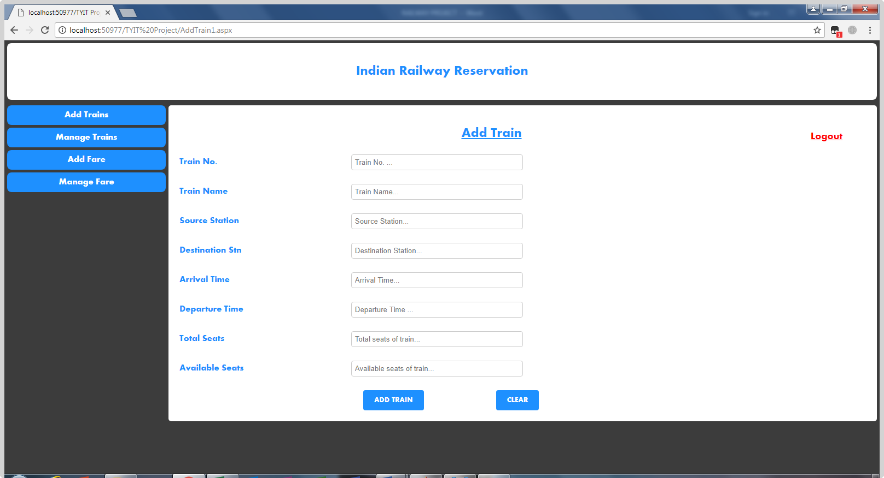

<%@ Page Language="C#" AutoEventWireup="true" CodeFile="AddTrain1.aspx.cs" Inherits="AddTrain1" %>

<!DOCTYPE html PUBLIC "-//W3C//DTD XHTML 1.0 Transitional//EN" "http://www.w3.org/TR/xhtml1/DTD/xhtml1-transitional.dtd">

<html xmlns="http://www.w3.org/1999/xhtml">

<head runat="server">

<title></title>

<link href="StyleSheet.css" rel="stylesheet" type="text/css" />

<style>

* {

box-sizing: border-box;

}

input[type=text], select, textarea{

width: 100%;

padding: 6px;

border: 1px solid #ccc;

border-radius: 4px;

box-sizing: border-box;

resize: vertical;

}

label {

padding: 6px 6px 6px 0;

color:DodgerBlue;

font-family:Aharoni;

display: inline-block;

}

input[type=submit] {

background-color:DodgerBlue;

color: white;

font-family:Aharoni;

margin-top:6px;

padding: 12px 20px;

border: none;

border-radius: 4px;

cursor: pointer;

align:center;

}

input[type=submit]:hover {

background-color:white;

color:DodgerBlue;

}

.ad_container {

border-radius: 5px;

background-color:white;

padding: 20px;

}

.col-25 {

float: left;

width: 25%;

margin-top: 6px;

}

.col-75 {

float: left;

width: 25%;

margin-top: 6px;

}

h3

{

color:Dodgerblue;

font-family:Aharoni;

}

.log

{

float:right;

margin-right:30px;

}

#Button3

{

padding:0px;

height: 24px;

}

</style>

</head>

<body>

<h2 class="header">Indian Railway Reservation</h2>

<div class="menu">

<ul>

<li><a href="AddTrain1.aspx">Add Trains</a></li>

<li><a href="ManageTrains.aspx">Manage Trains</a></li>

<li><a href="AddFare1.aspx">Add Fare</a></li>

<li><a href="Managefare.aspx">Manage Fare</a></li>

</ul>

</div>

<div class="ad_container">

<form id="form1" runat="server">

<div class="log">

<asp:Button ID="Button3" runat="server" Text="Logout" BackColor="White" ForeColor="Red"

onclick="Button3_Click" Visible="False" Font-Size="Large"

Font-Underline="True" Width="84px" onclientclick="welcome.aspx" /></div>

<h2 align="center"><u style="color: DodgerBlue; font-family: Aharoni">Add Train</u></h2>

<div class="row">

<div class="col-25">

<label for="fname">Train No.</label>

</div>

<div class="col-75">

<asp:TextBox ID="TextBox6" runat="server" placeholder="Train No. ..."></asp:TextBox>

</div>

<br />

<font style="padding-left:'65px'"><asp:RequiredFieldValidator runat="server" ErrorMessage="Train No. Must Not Be Empty"

ForeColor="red" ID="RequiredFieldValidator6"

ControlToValidate="TextBox6"></asp:RequiredFieldValidator>

</font>

</div>

<br />

<br />

<div class="row">

<div class="col-25">

<label for="fname">Train Name</label>

</div>

<div class="col-75">

<asp:TextBox ID="TextBox1" runat="server" placeholder="Train Name..."></asp:TextBox>

</div>

<br />

<font style="padding-left:'65px'"><asp:RequiredFieldValidator runat="server" ErrorMessage="Train Name Must Not Be Empty"

ForeColor="red" ID="RequiredFieldValidator1"

ControlToValidate="TextBox1"></asp:RequiredFieldValidator>

</font>

</div>

</br>

<br />

<div class="row">

<div class="col-25">

<label for="fname">Source Station</label>

</div>

<div class="col-75">

<asp:TextBox ID="TextBox2" runat="server" placeholder="Source Station..."></asp:TextBox>

</div>

<br />

<font><asp:RequiredFieldValidator runat="server" ErrorMessage="Source Station Must Not Be Empty"

ForeColor="red" ID="RequiredFieldValidator2"

ControlToValidate="TextBox1"></asp:RequiredFieldValidator></font>

</div>

</br>

<br />

<div class="row">

<div class="col-25">

<label for="fname">Destination Stn</label>

</div>

<div class="col-75">

<asp:TextBox ID="TextBox3" runat="server" placeholder="Destination Station..."></asp:TextBox>

</div>

<br />

<font>

<asp:RequiredFieldValidator runat="server" ErrorMessage="Destination Station Must Not Be Empty"

ForeColor="red" ID="RequiredFieldValidator3"

ControlToValidate="TextBox1"></asp:RequiredFieldValidator>

</font>

</div>

<br /><br />

<div class="row">

<div class="col-25">

<label for="fname">Arrival Time</label>

</div>

<div class="col-75">

<asp:TextBox ID="TextBox4" runat="server" placeholder="Arrival Time..."></asp:TextBox>

</div>

<br />

<font>

<asp:RequiredFieldValidator runat="server" ErrorMessage="Arrival Time Must Not Be Empty"

ForeColor="red" ID="RequiredFieldValidator5"

ControlToValidate="TextBox1"></asp:RequiredFieldValidator></font>

</div>

</br>

<br />

<div class="row">

<div class="col-25">

<label for="fname">Departure Time</label>

</div>

<div class="col-75">

<asp:TextBox ID="TextBox5" runat="server" placeholder="Departure Time ..."></asp:TextBox>

</div>

<br />

<font>

<asp:RequiredFieldValidator runat="server" ErrorMessage="Departure Time Must Not Be Empty"

ForeColor="red" ID="RequiredFieldValidator4"

ControlToValidate="TextBox1"></asp:RequiredFieldValidator></font>

</div>

</br>

<br />

<div class="row">

<div class="col-25">

<label for="fname">Total Seats</label>&nbsp;

</div>

<div class="col-75">

<asp:TextBox ID="TextBox7" runat="server" placeholder="Total seats of train..."></asp:TextBox>

</div>

<br />

<font style="padding-left:'65px'"><asp:RequiredFieldValidator runat="server" ErrorMessage="Train seats Must Not Be Empty"

ForeColor="red" ID="RequiredFieldValidator7"

ControlToValidate="TextBox7"></asp:RequiredFieldValidator>

</font>

</div>

</br>

<br />

<div class="row">

<div class="col-25">

<label for="fname">Available Seats</label>&nbsp;

</div>

<div class="col-75">

<asp:TextBox ID="TextBox8" runat="server" placeholder="Available seats of train..."></asp:TextBox>

</div>

<br />

<font style="padding-left:'65px'"><asp:RequiredFieldValidator runat="server" ErrorMessage="Train seats Must Not Be Empty"

ForeColor="red" ID="RequiredFieldValidator8"

ControlToValidate="TextBox8"></asp:RequiredFieldValidator>

</font>

</div>

</br>

<br />

<div class="row">

&nbsp;&nbsp;&nbsp;&nbsp;&nbsp;&nbsp;&nbsp;&nbsp;&nbsp;&nbsp;&nbsp;&nbsp;&nbsp;&nbsp;&nbsp;&nbsp;&nbsp;&nbsp;&nbsp;&nbsp;&nbsp;&nbsp;&nbsp;&nbsp;&nbsp;&nbsp;&nbsp;&nbsp;&nbsp;&nbsp;&nbsp;&nbsp;&nbsp;&nbsp;&nbsp;&nbsp;&nbsp;&nbsp;&nbsp;&nbsp;&nbsp;&nbsp;&nbsp;&nbsp;&nbsp;&nbsp;&nbsp;&nbsp;&nbsp;&nbsp;&nbsp;&nbsp;&nbsp;&nbsp;&nbsp;&nbsp;&nbsp;&nbsp;&nbsp;&nbsp;&nbsp;&nbsp;&nbsp;&nbsp;&nbsp;&nbsp;&nbsp;&nbsp;&nbsp;&nbsp;&nbsp;&nbsp;&nbsp;&nbsp;&nbsp;&nbsp;&nbsp;&nbsp;&nbsp;&nbsp;&nbsp;&nbsp;&nbsp;

<asp:Button ID="Button1" runat="server" Text="ADD TRAIN" onclick="Button1_Click" />

&nbsp;&nbsp;&nbsp;&nbsp;&nbsp;&nbsp;&nbsp;&nbsp;&nbsp;&nbsp;&nbsp;&nbsp;&nbsp;&nbsp;&nbsp;&nbsp;&nbsp;&nbsp;&nbsp;&nbsp;&nbsp;&nbsp;&nbsp;&nbsp;&nbsp;&nbsp;&nbsp;&nbsp;&nbsp;&nbsp;&nbsp;

<asp:Button ID="Button2" runat="server" Text="CLEAR" onclick="Button2_Click" />

</div>

</form>

</div>

</body>

</html>

1. **AddFare.aspx**

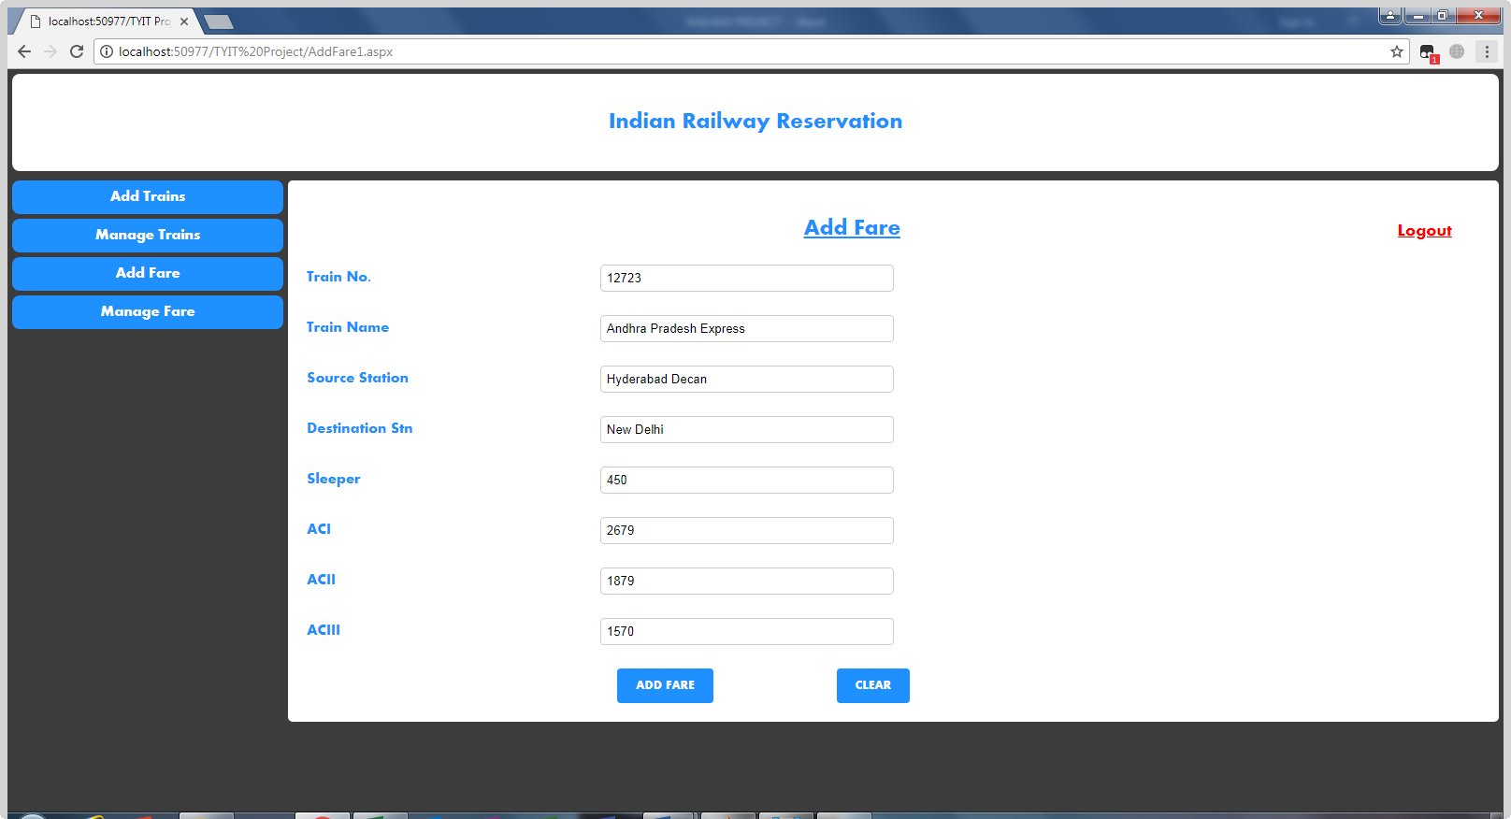

<%@ Page Language="C#" AutoEventWireup="true" CodeFile="AddFare1.aspx.cs" Inherits="AddFare1" %>

<!DOCTYPE html PUBLIC "-//W3C//DTD XHTML 1.0 Transitional//EN" "http://www.w3.org/TR/xhtml1/DTD/xhtml1-transitional.dtd">

<html xmlns="http://www.w3.org/1999/xhtml">

<head runat="server">

<title></title>

<link href="StyleSheet.css" rel="stylesheet" type="text/css" />

<style>

* {

box-sizing: border-box;

}

input[type=text], select, textarea{

width: 100%;

padding: 6px;

border: 1px solid #ccc;

border-radius: 4px;

box-sizing: border-box;

resize: vertical;

}

label {

padding: 6px 6px 6px 0;

color:DodgerBlue;

font-family:Aharoni;

display: inline-block;

}

input[type=submit] {

background-color:DodgerBlue;

color: white;

font-family:Aharoni;

margin-top:6px;

padding: 12px 20px;

border: none;

border-radius: 4px;

cursor: pointer;

align:center;

}

input[type=submit]:hover {

background-color:white;

color:DodgerBlue;

}

.ad_container {

border-radius: 5px;

background-color:white;

padding: 20px;

}

.col-25 {

float: left;

width: 25%;

margin-top: 6px;

}

.col-75 {

float: left;

width: 25%;

margin-top: 6px;

}

h3

{

margin-top:20px;

color:Dodgerblue;

font-family:Aharoni;

}

.log

{

float:right;

margin-right:30px;

}

#Button3

{

padding:0;

}

</style>

</head>

<body>

<h2 class="header">Indian Railway Reservation</h2>

<div class="menu">

<ul>

<li><a href="AddTrain1.aspx">Add Trains</a></li>

<li><a href="ManageTrains.aspx">Manage Trains</a></li>

<li><a href="AddFare1.aspx">Add Fare</a></li>

<li><a href="Managefare.aspx">Manage Fare</a></li>

</ul>

</div>

<div class="ad_container">

<form id="form1" runat="server">

<div class="log">

<asp:Button ID="Button3" runat="server" Text="Logout" BackColor="White" ForeColor="Red"

onclick="Button3_Click" Font-Size="Large"

Font-Underline="True" onclientclick="welcome.aspx" Visible="False" /></div>

<h2 align="center"><u style="color: DodgerBlue; font-family: Aharoni">Add Fare</u></h2>

<div class="row">

<div class="col-25">

<label for="fname">Train No.</label>

</div>

<div class="col-75">

<asp:TextBox ID="txttrainno" runat="server" placeholder="Train No. ..."

AutoPostBack="True"></asp:TextBox>

</div>

<br />

<font style="padding-left:'65px'">

<asp:RequiredFieldValidator runat="server" ErrorMessage="Train No. Must Not Be Empty"

ForeColor="red" ID="RequiredFieldValidator6"

ControlToValidate="txttrainno"></asp:RequiredFieldValidator>

</font>

</div>

<br />

<br />

<div class="row">

<div class="col-25">

<label for="fname">Train Name</label>

</div>

<div class="col-75">

<asp:TextBox ID="txttrainname" runat="server" placeholder="Train Name..."></asp:TextBox>

</div>

<br />

<font style="padding-left:'65px'">

<asp:RequiredFieldValidator runat="server" ErrorMessage="Train Name Must Not Be Empty"

ForeColor="red" ID="RequiredFieldValidator1"

ControlToValidate="txttrainname"></asp:RequiredFieldValidator>

</font>

</div>

<br />

<br />

<div class="row">

<div class="col-25">

<label for="fname">Source Station</label>

</div>

<div class="col-75">

<asp:TextBox ID="txtsourcestn" runat="server" placeholder="Source Station..."></asp:TextBox>

</div>

<br />

<font style="padding-left:'65px'">

<asp:RequiredFieldValidator runat="server" ErrorMessage="Source Station Must Not Be Empty"

ForeColor="red" ID="RequiredFieldValidator2"

ControlToValidate="txtsourcestn"></asp:RequiredFieldValidator></font>

</div>

<br />

<br />

<div class="row">

<div class="col-25">

<label for="fname">Destination Stn</label>

</div>

<div class="col-75">

<asp:TextBox ID="txtdest" runat="server" placeholder="Destination Station..."></asp:TextBox>

</div>

<br />

<font style="padding-left:'65px'">

<asp:RequiredFieldValidator runat="server" ErrorMessage="Destination Station Must Not Be Empty"

ForeColor="red" ID="RequiredFieldValidator3"

ControlToValidate="txtdest"></asp:RequiredFieldValidator>

</font>

</div>

<br />

<br />

<div class="row">

<div class="col-25">

<label for="fname">Sleeper</label>

</div>

<div class="col-75">

<asp:TextBox ID="txtsleeper" runat="server" placeholder="SLEEPER FARE"></asp:TextBox>

</div>

<br />

<font style="padding-left:'65px'">

<asp:RequiredFieldValidator runat="server" ErrorMessage="Sleeper Fare Must Not Be Empty"

ForeColor="red" ID="RequiredFieldValidator4"

ControlToValidate="txtsleeper"></asp:RequiredFieldValidator></font>

</div>

<br />

<br />

<div class="row">

<div class="col-25">

<label for="fname">ACI</label>&nbsp;

</div>

<div class="col-75">

<asp:TextBox ID="ACI" runat="server" placeholder="ACI FARE"></asp:TextBox>

</div>

<br />

<font style="padding-left:'65px'">

<asp:RequiredFieldValidator runat="server" ErrorMessage="ACI Fare Must Not Be Empty"

ForeColor="red" ID="RequiredFieldValidator7"

ControlToValidate="ACI"></asp:RequiredFieldValidator>

</font>

</div>

<br />

<br />

<div class="row">

<div class="col-25">

<label for="fname">ACII</label>&nbsp;

</div>

<div class="col-75">

<asp:TextBox ID="ACII" runat="server" placeholder="ACII FARE"></asp:TextBox>

</div>

<br />

<font style="padding-left:'65px'">

<asp:RequiredFieldValidator runat="server" ErrorMessage="ACII Fare Must Not Be Empty"

ForeColor="red" ID="RequiredFieldValidator8"

ControlToValidate="ACII"></asp:RequiredFieldValidator>

</font>

</div>

<br />

<br />

<div class="row">

<div class="col-25">

<label for="fname">ACIII</label>&nbsp;

</div>

<div class="col-75">

<asp:TextBox ID="ACIII" runat="server" placeholder="ACIII PRICE"></asp:TextBox>

</div>

<br />

<font style="padding-left:'65px'">

<asp:RequiredFieldValidator runat="server" ErrorMessage="ACIII Price Must Not Be Empty"

ForeColor="red" ID="RequiredFieldValidator9"

ControlToValidate="ACIII"></asp:RequiredFieldValidator>

</font>

</div>

<br />

<br />

<div class="row">

&nbsp;&nbsp;&nbsp;&nbsp;&nbsp;&nbsp;&nbsp;&nbsp;&nbsp;&nbsp;&nbsp;&nbsp;&nbsp;&nbsp;&nbsp;&nbsp;&nbsp;&nbsp;&nbsp;&nbsp;&nbsp;&nbsp;&nbsp;&nbsp;&nbsp;&nbsp;&nbsp;&nbsp;&nbsp;&nbsp;&nbsp;&nbsp;&nbsp;&nbsp;&nbsp;&nbsp;&nbsp;&nbsp;&nbsp;&nbsp;&nbsp;&nbsp;&nbsp;&nbsp;&nbsp;&nbsp;&nbsp;&nbsp;&nbsp;&nbsp;&nbsp;&nbsp;&nbsp;&nbsp;&nbsp;&nbsp;&nbsp;&nbsp;&nbsp;&nbsp;&nbsp;&nbsp;&nbsp;&nbsp;&nbsp;&nbsp;&nbsp;&nbsp;&nbsp;&nbsp;&nbsp;&nbsp;&nbsp;&nbsp;&nbsp;&nbsp;&nbsp;&nbsp;&nbsp;&nbsp;&nbsp;&nbsp;

<asp:Button ID="Button1" runat="server" Text="ADD FARE" onclick="Button1_Click" />

&nbsp;&nbsp;&nbsp;&nbsp;&nbsp;&nbsp;&nbsp;&nbsp;&nbsp;&nbsp;&nbsp;&nbsp;&nbsp;&nbsp;&nbsp;&nbsp;&nbsp;&nbsp;&nbsp;&nbsp;&nbsp;&nbsp;&nbsp;&nbsp;&nbsp;&nbsp;&nbsp;&nbsp;&nbsp;&nbsp;&nbsp;

<asp:Button ID="Button2" runat="server" Text="CLEAR" onclick="Button2_Click" />

</div>

</form>

</div>

</body>

</html>

1. **Manage Train by admin**

**ManageTrain.aspx**

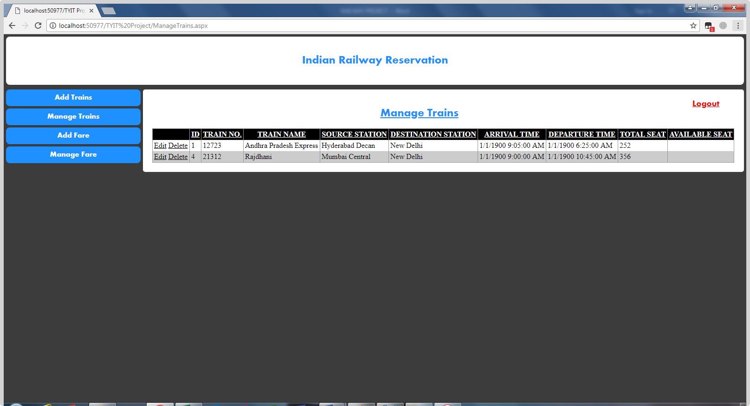

<%@ Page Language="C#" AutoEventWireup="true" CodeFile="ManageTrains.aspx.cs" Inherits="ManageTrains" %>

<!DOCTYPE html PUBLIC "-//W3C//DTD XHTML 1.0 Transitional//EN" "http://www.w3.org/TR/xhtml1/DTD/xhtml1-transitional.dtd">

<html xmlns="http://www.w3.org/1999/xhtml">

<head runat="server">

<title></title>

<link href="StyleSheet.css" rel="stylesheet" type="text/css" />

<style>

.ad_container {

border-radius: 5px;

background-color:white;

padding: 20px;

}

input[type=submit] {

background-color: DodgerBlue;

color: white;

font-family:Aharoni;

padding: 20px 30px;

border: none;

border-radius: 4px;

}

.log

{

float:right;

margin-right:20px;

}

#Button1

{

padding:0px;

height: 24px;

}

</style>

</head>

<body>

<h2 class="header">Indian Railway Reservation</h2>

<form id="form1" runat="server">

<div class="menu">

<ul>

<li><a href="AddTrain1.aspx">Add Trains</a></li>

<li><a href="ManageTrains.aspx">Manage Trains</a></li>

<li><a href="AddFare1.aspx">Add Fare</a></li>

<li><a href="Managefare.aspx">Manage Fare</a></li>

</ul>

</div>

<div class="ad_container">

<div class="log">

<asp:Button ID="Button1" runat="server" Text="Logout" BackColor="White" ForeColor="Red"

onclick="Button1_Click" Visible="False" Font-Size="Large"

Font-Underline="True" Width="84px"/></div>

<h2 align="center"><u style="color: DodgerBlue; font-family: Aharoni">Manage Trains</u></h2>

<asp:GridView ID="GridView1" runat="server" AllowPaging="True"

AllowSorting="True" AutoGenerateColumns="False" BackColor="White"

BorderColor="#999999" BorderStyle="Solid" BorderWidth="1px" CellPadding="3"

DataKeyNames="ID" DataSourceID="SqlDataSource1" ForeColor="Black"

GridLines="Vertical">

<AlternatingRowStyle BackColor="#CCCCCC" />

<Columns>

<asp:CommandField ShowDeleteButton="True" ShowEditButton="True" />

<asp:BoundField DataField="ID" HeaderText="ID" InsertVisible="False"

ReadOnly="True" SortExpression="ID" />

<asp:BoundField DataField="train_no" HeaderText="TRAIN NO."

SortExpression="train_no" />

<asp:BoundField DataField="train_name" HeaderText="TRAIN NAME"

SortExpression="train_name" />

<asp:BoundField DataField="source_stn" HeaderText="SOURCE STATION"

SortExpression="source_stn" />

<asp:BoundField DataField="dest_stn" HeaderText="DESTINATION STATION"

SortExpression="dest_stn" />

<asp:BoundField DataField="arrl_time" HeaderText="ARRIVAL TIME"

SortExpression="arrl_time" />

<asp:BoundField DataField="dep_time" HeaderText="DEPARTURE TIME"

SortExpression="dep_time" />

<asp:BoundField DataField="total_seat" HeaderText="TOTAL SEAT"

SortExpression="total_seat" />

<asp:BoundField DataField="avail_seat" HeaderText="AVAILABLE SEAT"

SortExpression="avail_seat" />

</Columns>

<FooterStyle BackColor="#CCCCCC" />

<HeaderStyle BackColor="Black" Font-Bold="True" ForeColor="White" />

<PagerStyle BackColor="#999999" ForeColor="Black" HorizontalAlign="Center" />

<SelectedRowStyle BackColor="#000099" Font-Bold="True" ForeColor="White" />

<SortedAscendingCellStyle BackColor="#F1F1F1" />

<SortedAscendingHeaderStyle BackColor="#808080" />

<SortedDescendingCellStyle BackColor="#CAC9C9" />

<SortedDescendingHeaderStyle BackColor="#383838" />

</asp:GridView>

<asp:SqlDataSource ID="SqlDataSource1" runat="server"

ConnectionString="<%$ ConnectionStrings:ConnectionString %>"

DeleteCommand="DELETE FROM [trains] WHERE [ID] = @ID"

InsertCommand="INSERT INTO [trains] ([train_no], [train_name], [source_stn], [dest_stn], [arrl_time], [dep_time], [total_seat], [avail_seat]) VALUES (@train_no, @train_name, @source_stn, @dest_stn, @arrl_time, @dep_time, @total_seat, @avail_seat)"

SelectCommand="SELECT * FROM [trains]"

UpdateCommand="UPDATE [trains] SET [train_no] = @train_no, [train_name] = @train_name, [source_stn] = @source_stn, [dest_stn] = @dest_stn, [arrl_time] = @arrl_time, [dep_time] = @dep_time, [total_seat] = @total_seat, [avail_seat] = @avail_seat WHERE [ID] = @ID">

<DeleteParameters>

<asp:Parameter Name="ID" Type="Int32" />

</DeleteParameters>

<InsertParameters>

<asp:Parameter Name="train_no" Type="Int32" />

<asp:Parameter Name="train_name" Type="String" />

<asp:Parameter Name="source_stn" Type="String" />

<asp:Parameter Name="dest_stn" Type="String" />

<asp:Parameter Name="arrl_time" Type="DateTime" />

<asp:Parameter Name="dep_time" Type="DateTime" />

<asp:Parameter Name="total_seat" Type="Int32" />

<asp:Parameter Name="avail_seat" Type="Int32" />

</InsertParameters>

<UpdateParameters>

<asp:Parameter Name="train_no" Type="Int32" />

<asp:Parameter Name="train_name" Type="String" />

<asp:Parameter Name="source_stn" Type="String" />

<asp:Parameter Name="dest_stn" Type="String" />

<asp:Parameter Name="arrl_time" Type="DateTime" />

<asp:Parameter Name="dep_time" Type="DateTime" />

<asp:Parameter Name="total_seat" Type="Int32" />

<asp:Parameter Name="avail_seat" Type="Int32" />

<asp:Parameter Name="ID" Type="Int32" />

</UpdateParameters>

</asp:SqlDataSource>

</div>

</form>

</body>

</html>

1. **ManageFare.aspx**

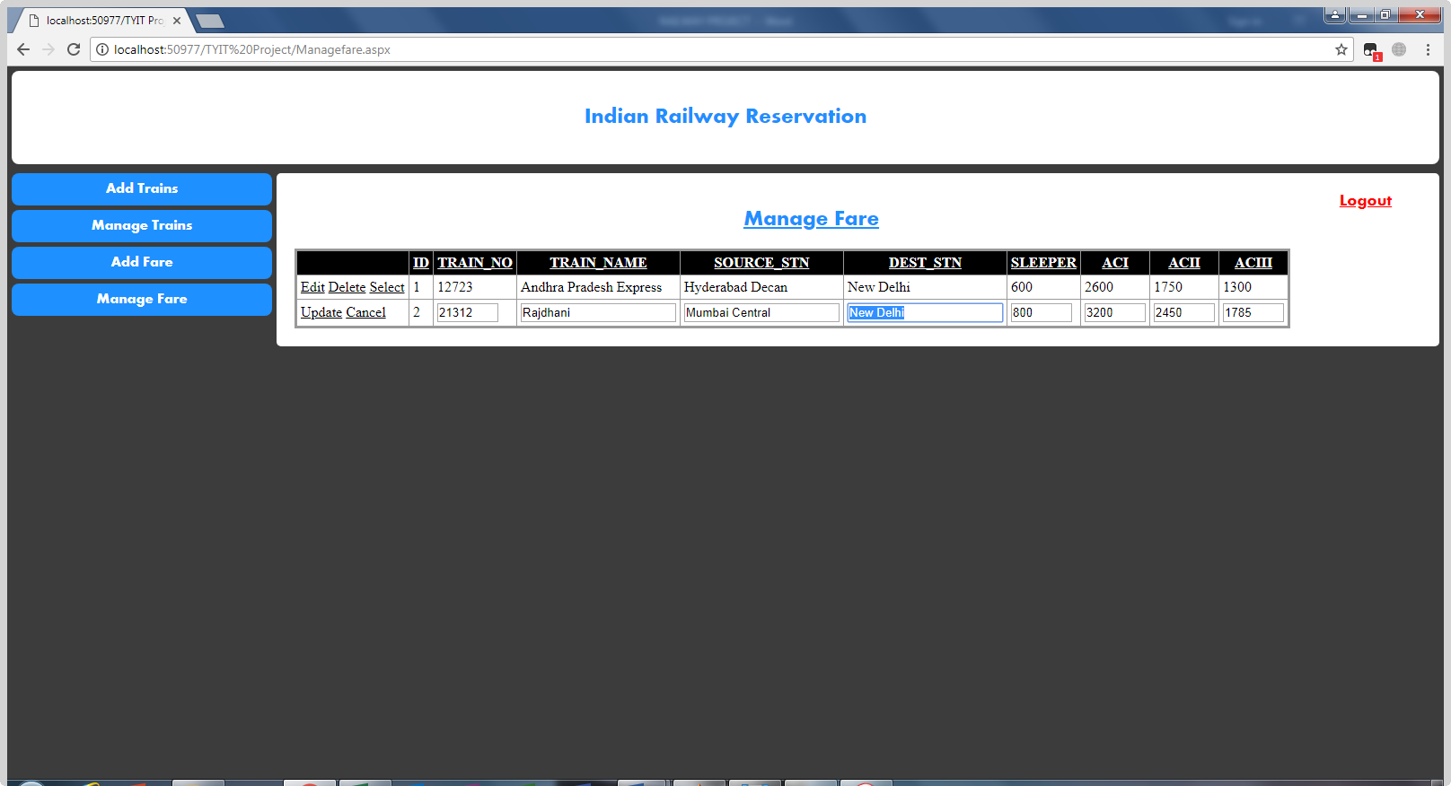

<%@ Page Language="C#" AutoEventWireup="true" CodeFile="Managefare.aspx.cs" Inherits="Managefare" %>

<!DOCTYPE html PUBLIC "-//W3C//DTD XHTML 1.0 Transitional//EN" "http://www.w3.org/TR/xhtml1/DTD/xhtml1-transitional.dtd">

<html xmlns="http://www.w3.org/1999/xhtml">

<head runat="server">

<title></title>

<link href="StyleSheet.css" rel="stylesheet" type="text/css" />

<style>

.ad_container {

border-radius: 5px;

background-color:white;

padding: 20px;

}

input[type=submit] {

background-color: DodgerBlue;

color: white;

font-family:Aharoni;

padding: 20px 30px;

border: none;

border-radius: 4px;

}

.log

{

float:right;

margin-right:20px;

}

#Button1

{

padding:0px;

height: 24px;

}

</style>

</head>

<body>

<form id="form1" runat="server">

<h2 class="header">Indian Railway Reservation</h2>

<div class="menu">

<ul>

<li><a href="AddTrain1.aspx">Add Trains</a></li>

<li><a href="ManageTrains.aspx">Manage Trains</a></li>

<li><a href="AddFare1.aspx">Add Fare</a></li>

<li><a href="Managefare.aspx">Manage Fare</a></li>

</ul>

</div>

<div class="ad_container">

<div class="log">

<asp:Button ID="Button1" runat="server" Text="Logout" BackColor="White" ForeColor="Red"

onclick="Button1_Click" Visible="False" Font-Size="Large"

Font-Underline="True" Width="84px" /></div>

<h2 align="center"><u style="color: DodgerBlue; font-family: Aharoni">Manage Fare</u></h2>

<asp:GridView ID="GridView1" runat="server" AllowPaging="True"

AllowSorting="True" AutoGenerateColumns="False" BackColor="#CCCCCC"

BorderColor="#999999" BorderStyle="Solid" BorderWidth="3px" CellPadding="4"

CellSpacing="2" DataKeyNames="ID" DataSourceID="SqlDataSource1"

ForeColor="Black">

<Columns>

<asp:CommandField ShowDeleteButton="True" ShowEditButton="True"

ShowSelectButton="True" />

<asp:BoundField DataField="ID" HeaderText="ID" InsertVisible="False"

ReadOnly="True" SortExpression="ID" />

<asp:BoundField DataField="TRAIN_NO" HeaderText="TRAIN_NO"

SortExpression="TRAIN_NO" />

<asp:BoundField DataField="TRAIN_NAME" HeaderText="TRAIN_NAME"

SortExpression="TRAIN_NAME" />

<asp:BoundField DataField="SOURCE_STN" HeaderText="SOURCE_STN"

SortExpression="SOURCE_STN" />

<asp:BoundField DataField="DEST_STN" HeaderText="DEST_STN"

SortExpression="DEST_STN" />

<asp:BoundField DataField="SLEEPER" HeaderText="SLEEPER"

SortExpression="SLEEPER" />

<asp:BoundField DataField="ACI" HeaderText="ACI" SortExpression="ACI" />

<asp:BoundField DataField="ACII" HeaderText="ACII" SortExpression="ACII" />

<asp:BoundField DataField="ACIII" HeaderText="ACIII" SortExpression="ACIII" />

</Columns>

<FooterStyle BackColor="#CCCCCC" />

<HeaderStyle BackColor="Black" Font-Bold="True" ForeColor="White" />

<PagerStyle BackColor="#CCCCCC" ForeColor="Black" HorizontalAlign="Left" />

<RowStyle BackColor="White" />

<SelectedRowStyle BackColor="#000099" Font-Bold="True" ForeColor="White" />

<SortedAscendingCellStyle BackColor="#F1F1F1" />

<SortedAscendingHeaderStyle BackColor="#808080" />

<SortedDescendingCellStyle BackColor="#CAC9C9" />

<SortedDescendingHeaderStyle BackColor="#383838" />

</asp:GridView>

<asp:SqlDataSource ID="SqlDataSource1" runat="server"

ConnectionString="<%$ ConnectionStrings:ConnectionString %>"

DeleteCommand="DELETE FROM [FARE] WHERE [ID] = @ID"

InsertCommand="INSERT INTO [FARE] ([TRAIN_NO], [TRAIN_NAME], [SOURCE_STN], [DEST_STN], [SLEEPER], [ACI], [ACII], [ACIII]) VALUES (@TRAIN_NO, @TRAIN_NAME, @SOURCE_STN, @DEST_STN, @SLEEPER, @ACI, @ACII, @ACIII)"

SelectCommand="SELECT * FROM [FARE]"

UpdateCommand="UPDATE [FARE] SET [TRAIN_NO] = @TRAIN_NO, [TRAIN_NAME] = @TRAIN_NAME, [SOURCE_STN] = @SOURCE_STN, [DEST_STN] = @DEST_STN, [SLEEPER] = @SLEEPER, [ACI] = @ACI, [ACII] = @ACII, [ACIII] = @ACIII WHERE [ID] = @ID">

<DeleteParameters>

<asp:Parameter Name="ID" Type="Int32" />

</DeleteParameters>

<InsertParameters>

<asp:Parameter Name="TRAIN_NO" Type="Int32" />

<asp:Parameter Name="TRAIN_NAME" Type="String" />

<asp:Parameter Name="SOURCE_STN" Type="String" />

<asp:Parameter Name="DEST_STN" Type="String" />

<asp:Parameter Name="SLEEPER" Type="String" />

<asp:Parameter Name="ACI" Type="String" />

<asp:Parameter Name="ACII" Type="String" />

<asp:Parameter Name="ACIII" Type="String" />

</InsertParameters>

<UpdateParameters>

<asp:Parameter Name="TRAIN_NO" Type="Int32" />

<asp:Parameter Name="TRAIN_NAME" Type="String" />

<asp:Parameter Name="SOURCE_STN" Type="String" />

<asp:Parameter Name="DEST_STN" Type="String" />

<asp:Parameter Name="SLEEPER" Type="String" />

<asp:Parameter Name="ACI" Type="String" />

<asp:Parameter Name="ACII" Type="String" />

<asp:Parameter Name="ACIII" Type="String" />

<asp:Parameter Name="ID" Type="Int32" />

</UpdateParameters>

</asp:SqlDataSource>

</div>

</form>

</body>

</html>

**Search Train**

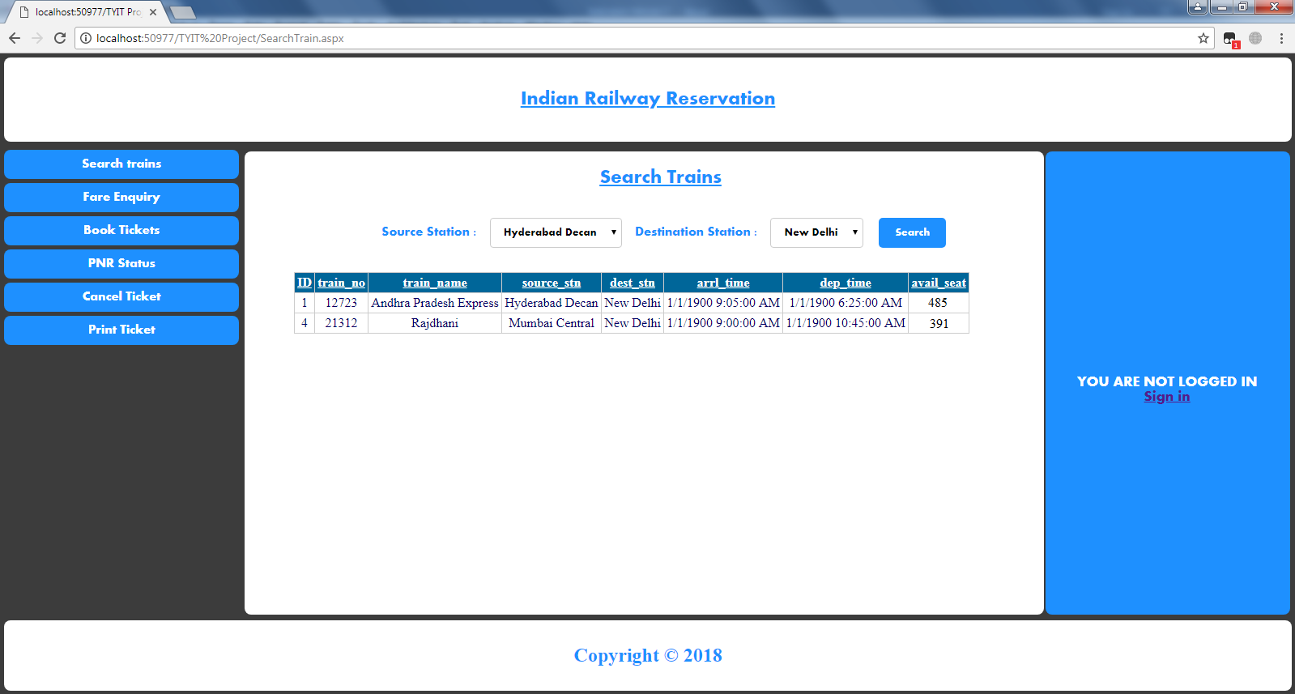

<%@ Page Title="" Language="C#" MasterPageFile="~/MasterPage.master" AutoEventWireup="true" CodeFile="SearchTrain.aspx.cs" Inherits="Default2" %>

<asp:Content ID="Content1" ContentPlaceHolderID="head" Runat="Server">

</asp:Content>

<asp:Content ID="Content2" ContentPlaceHolderID="MainContentPlaceHolder" Runat="Server">

<style>

label

{

padding:12px;

box-border:;

border-radius:5px;

align:center;

}

.dropdown

{

padding: 10px 12px;

border: 1px solid #ccc;

border-radius: 4px;

box-sizing: border-box;

resize: vertical;

align:center;

font-family:Aharoni;

}

input[type=submit]

{

padding: 12px 20px;

border:none;

border-radius:5px;

align:center;

color:White;

cursor:pointer;

font-family:Aharoni;

margin-left:15px;

background-color:DodgerBlue;

}

#Button2

{

padding:0;

}

input[type=submit]:hover

{

background-color:White;

color:Dodgerblue;

}

.container

{

padding:20px;

margin-top:0;

}

.grid

{

align:center;

margin-top:30px;

margin-left:40px;

}

h3

{

margin-top:0;

}

.log

{

float:right;

margin-right:30px;

}

</style>

<div class="container">

<form id="form1" runat="server">

<div class="log">

<asp:Button ID="Button2" runat="server" Text="Logout" BackColor="White" ForeColor="Red"

onclick="Button2_Click" Visible="False" Font-Size="Large"

Font-Underline="True" /></div>

<h3 style="font-family:Aharoni; text-align:center; color: DodgerBlue;"><b>

<u style="font-size: x-large">Search Trains</u></b></h3>

<br />

<label style="font-family: aharoni; color: Dodgerblue;">Source Station :</label>

<asp:DropDownList ID="DropDownList1" class="dropdown" runat="server"

DataSourceID="SqlDataSource1" DataTextField="source_stn"

DataValueField="source_stn">

<asp:ListItem>Source</asp:ListItem>

</asp:DropDownList>

<label style="font-family: aharoni; color: Dodgerblue;">Destination Station :</label>

<asp:DropDownList ID="DropDownList2" class="dropdown" runat="server"

DataSourceID="SqlDataSource1" DataTextField="dest_stn"

DataValueField="dest_stn">

<asp:ListItem>Destination</asp:ListItem>

</asp:DropDownList>

<asp:Button ID="Button1" runat="server" Text="Search" onclick="Button1_Click" />

<asp:SqlDataSource ID="SqlDataSource2" runat="server"

ConnectionString="<%$ ConnectionStrings:ConnectionString %>"

SelectCommand="SELECT * FROM [trains]"></asp:SqlDataSource>

<asp:SqlDataSource ID="SqlDataSource1" runat="server"

ConnectionString="<%$ ConnectionStrings:ConnectionString %>"

SelectCommand="SELECT [source_stn], [dest_stn] FROM [trains]"></asp:SqlDataSource>

<br />

<div class="grid">

<asp:GridView ID="GridView1" runat="server" AllowPaging="True"

AllowSorting="True" AutoGenerateColumns="False" BackColor="White"

BorderColor="#CCCCCC" BorderStyle="None" BorderWidth="1px" CellPadding="3"

DataSourceID="SqlDataSource2">

<FooterStyle BackColor="White" ForeColor="#000066" />

<HeaderStyle BackColor="#006699" Font-Bold="True" ForeColor="White" />

<PagerStyle BackColor="White" ForeColor="#000066" HorizontalAlign="Left" />

<RowStyle ForeColor="#000066" />

<SelectedRowStyle BackColor="#669999" Font-Bold="True" ForeColor="White" />

<SortedAscendingCellStyle BackColor="#F1F1F1" />

<SortedAscendingHeaderStyle BackColor="#007DBB" />

<SortedDescendingCellStyle BackColor="#CAC9C9" />

<SortedDescendingHeaderStyle BackColor="#00547E" />

</asp:GridView>

</div>

</form>

</div>

</asp:Content>

<asp:Content ID="Content3" ContentPlaceHolderID="ContentPlaceHolder2" Runat="Server">

&nbsp

<div align="center" style="font-family: Aharoni;">

<asp:Label ID="Label1" runat="server"></asp:Label>

</div>

</asp:Content>

**Fare Enquiry**

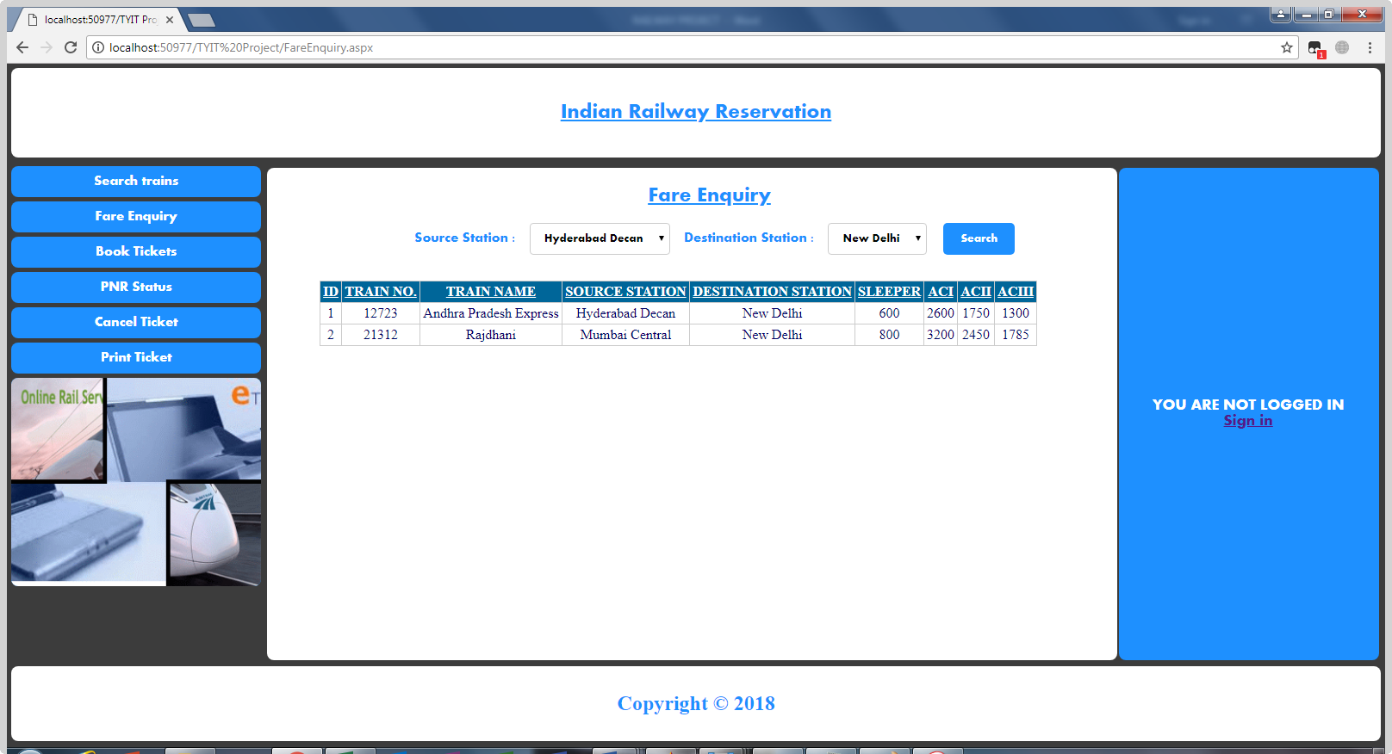

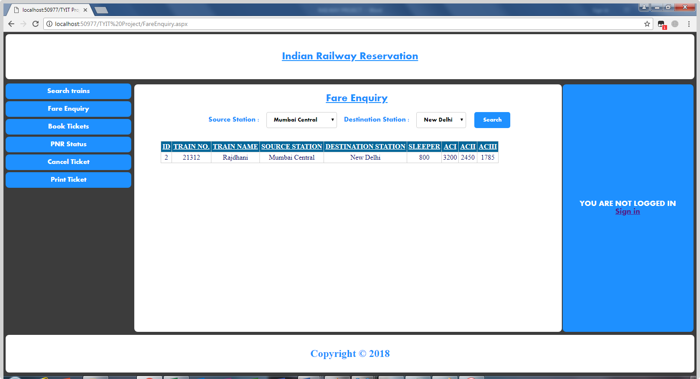

<%@ Page Title="" Language="C#" MasterPageFile="~/MasterPage.master" AutoEventWireup="true" CodeFile="FareEnquiry.aspx.cs" Inherits="FareEnquiry" %>

<asp:Content ID="Content1" ContentPlaceHolderID="head" Runat="Server">

</asp:Content>

<asp:Content ID="Content2" ContentPlaceHolderID="MainContentPlaceHolder" Runat="Server">

<style>

label

{

padding:12px;

border-radius:5px;

}

.dropdown

{

padding: 10px 12px;

border: 1px solid #ccc;

border-radius: 4px;

box-sizing: border-box;

resize: vertical;

align:center;

font-family:Aharoni;

}

input[type=submit]

{

padding: 12px 20px;

border:none;

border-radius:5px;

align:center;

color:White;

cursor:pointer;

font-family:Aharoni;

margin-left:15px;

background-color:DodgerBlue;

}

input[type=submit]:hover

{

background-color:White;

color:Dodgerblue;

}

.container

{

padding:20px;

margin:0;

}

.grid

{

margin-top:30px;

margin-left:40px;

}

h3

{

margin-top:0;

}

.log

{

float:right;

margin-right:30px;

}

#Button2

{

padding:0;

}

</style>

<div class="container">

<form id="form1" runat="server">

<div class="log">

<asp:Button ID="Button2" runat="server" Text="Logout" BackColor="White" ForeColor="Red"

onclick="Button2_Click" Visible="False" Font-Size="Large"

Font-Underline="True" /></div>

<h3 style="font-family:Aharoni; text-align:center; color: DodgerBlue;"><b>

<u style="font-size: x-large">Fare Enquiry</u></b></h3>

<label style="font-family: aharoni; color: Dodgerblue;">Source Station :</label>

<asp:DropDownList ID="DropDownList1" class="dropdown" runat="server"

DataSourceID="SqlDataSource1" DataTextField="SOURCE_STN"

DataValueField="SOURCE_STN" >

<asp:ListItem>--Select--</asp:ListItem>

<asp:ListItem></asp:ListItem>

</asp:DropDownList>

<label style="font-family: aharoni; color: Dodgerblue;">Destination Station :</label>

<asp:DropDownList ID="DropDownList2" class="dropdown" runat="server"

DataSourceID="SqlDataSource1" DataTextField="DEST_STN"

DataValueField="DEST_STN">

<asp:ListItem>--Select--</asp:ListItem>

<asp:ListItem></asp:ListItem>

</asp:DropDownList>

<asp:Button ID="Button1" runat="server" Text="Search" onclick="Button1_Click" />

<asp:SqlDataSource ID="SqlDataSource1" runat="server"

ConnectionString="<%$ ConnectionStrings:ConnectionString %>"

SelectCommand="SELECT [SOURCE_STN], [DEST_STN] FROM [FARE]"></asp:SqlDataSource>

<asp:SqlDataSource ID="SqlDataSource2" runat="server"

ConnectionString="<%$ ConnectionStrings:ConnectionString %>"

SelectCommand="SELECT * FROM [FARE]"></asp:SqlDataSource>

<div class="grid">

<asp:GridView ID="GridView1" runat="server" AllowPaging="True"

AllowSorting="True" AutoGenerateColumns="False" BackColor="White"

BorderColor="#CCCCCC" BorderStyle="None" BorderWidth="1px" CellPadding="3"

DataKeyNames="ID" DataSourceID="SqlDataSource2">

<Columns>

<asp:BoundField DataField="ID" HeaderText="ID" InsertVisible="False"

ReadOnly="True" SortExpression="ID" />

<asp:BoundField DataField="TRAIN_NO" HeaderText="TRAIN NO."

SortExpression="TRAIN_NO" />

<asp:BoundField DataField="TRAIN_NAME" HeaderText="TRAIN NAME"

SortExpression="TRAIN_NAME" />

<asp:BoundField DataField="SOURCE_STN" HeaderText="SOURCE STATION"

SortExpression="SOURCE_STN" />

<asp:BoundField DataField="DEST_STN" HeaderText="DESTINATION STATION"

SortExpression="DEST_STN" />

<asp:BoundField DataField="SLEEPER" HeaderText="SLEEPER"

SortExpression="SLEEPER" />

<asp:BoundField DataField="ACI" HeaderText="ACI" SortExpression="ACI" />

<asp:BoundField DataField="ACII" HeaderText="ACII" SortExpression="ACII" />

<asp:BoundField DataField="ACIII" HeaderText="ACIII" SortExpression="ACIII" />

</Columns>

<FooterStyle BackColor="White" ForeColor="#000066" />

<HeaderStyle BackColor="#006699" Font-Bold="True" ForeColor="White" />

<PagerStyle BackColor="White" ForeColor="#000066" HorizontalAlign="Left" />

<RowStyle ForeColor="#000066" />

<SelectedRowStyle BackColor="#669999" Font-Bold="True" ForeColor="White" />

<SortedAscendingCellStyle BackColor="#F1F1F1" />

<SortedAscendingHeaderStyle BackColor="#007DBB" />

<SortedDescendingCellStyle BackColor="#CAC9C9" />

<SortedDescendingHeaderStyle BackColor="#00547E" />

</asp:GridView>

</div>

</form>

</div>

</asp:Content>

<asp:Content ID="Content3" ContentPlaceHolderID="ContentPlaceHolder2" Runat="Server">

<div align="center" style="font-family: Aharoni;">

<asp:Label ID="Label1" runat="server"></asp:Label>

</div>

</asp:Content>

**Book Tickets**

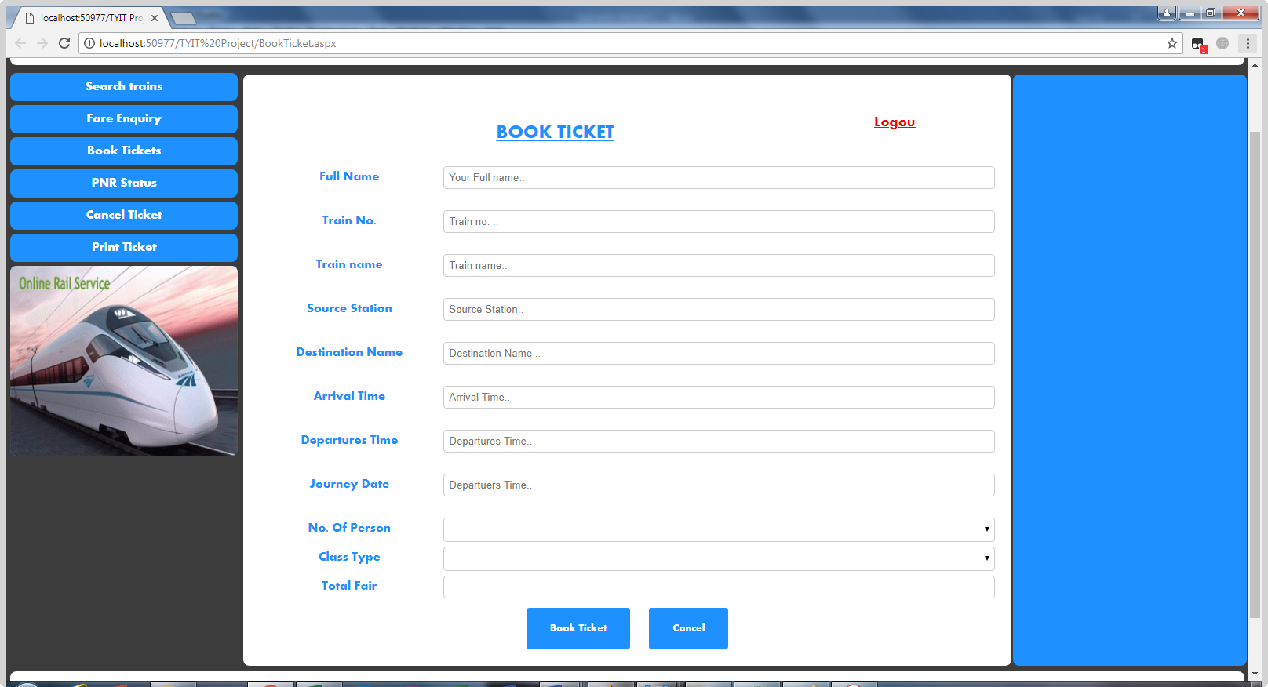

<%@ Page Title="" Language="C#" MasterPageFile="~/MasterPage.master" AutoEventWireup="true" CodeFile="BookTicket.aspx.cs" Inherits="BookTicket" %>

<asp:Content ID="Content1" ContentPlaceHolderID="head" Runat="Server">

</asp:Content>

<asp:Content ID="Content2" ContentPlaceHolderID="MainContentPlaceHolder" Runat="Server">

<style>

* {

box-sizing: border-box;

}

input[type=text], select, textarea{

width: 100%;

padding: 6px;

border: 1px solid #ccc;

border-radius: 4px;

box-sizing: border-box;

resize: vertical;

}

input[type=number], select, textarea{

width: 100%;

padding: 6px;

border: 1px solid #ccc;

border-radius: 4px;

box-sizing: border-box;

resize: vertical;

}

input[type=password], select, textarea{

width: 100%;

padding: 6px;

border: 1px solid #ccc;

border-radius: 4px;

box-sizing: border-box;

resize: vertical;

}

input[type=email], select, textarea{

width: 100%;

padding: 6px;

border: 1px solid #ccc;

border-radius: 4px;

box-sizing: border-box;

resize: vertical;

}

.date

{

width: 100%;

padding: 6px;

border: 1px solid #ccc;

border-radius: 4px;

box-sizing: border-box;

resize: vertical;

}

input[type=number], select, textarea{

width: 100%;

padding: 6px;

border: 1px solid #ccc;

border-radius: 4px;

box-sizing: border-box;

resize: vertical;

}

label {

padding: 6px 6px 6px 0;

color:DodgerBlue;

font-family:Aharoni;

display: inline-block;

}

input[type=submit] {

background-color: DodgerBlue;

color: white;

font-family:Aharoni;

margin-top:12px;

padding: 20px 30px;

border: none;

border-radius: 4px;

cursor: pointer;

}

input[type=submit]:hover {

background-color:white;

color:DodgerBlue;

}

.container {

border-radius: 5px;

background-color:white;

padding: 20px;

}

.col-25 {

float: left;

width: 25%;

margin-top: 6px;

}

.col-75 {

float: left;

width: 75%;

margin-top: 6px;

}

h3

{

color:Dodgerblue;

}

.container

{

background-color:White;

}

.log

{

float:right;

margin-right:100px;

}

#Button3

{

padding-top : 0;

padding : 0px;

margin:0px;

}

</style>

<div class="container">

<form id="form1" runat="server">

<div class="log">

<asp:Button ID="Button3" runat="server" Text="Logout " BackColor="White" ForeColor="Red"

onclick="Button3_Click" Visible="False" Font-Size="Large"

Font-Underline="True" Width="84px" onclientclick="welcome.aspx" /></div>

<br />

<h3 style=" font-size: x-large; font-family: Aharoni; text-decoration: underline">

BOOK TICKET</h3>

<div class="row">

<div class="col-25">

<label for="fname">Full Name</label>

</div>

<div class="col-75">

<asp:TextBox ID="TextBox1" runat="server" placeholder="Your Full name.."></asp:TextBox>

<asp:RequiredFieldValidator runat="server" ErrorMessage="Your Name Must Not Be Empty"

ForeColor="Red" ID="RequiredFieldValidator1" Font-Italic="True"

ControlToValidate="TextBox1"></asp:RequiredFieldValidator>

</div>

</div>

<div class="row">

<div class="col-25">

<label for="fname">Train No.</label>

</div>

<div class="col-75">

<asp:TextBox ID="TextBox2" runat="server" placeholder="Train no. .."

AutoPostBack="True"></asp:TextBox>

<asp:RequiredFieldValidator ID="RequiredFieldValidator2" runat="server"

ErrorMessage="Please Enter Train Number .." Font-Italic="True" ForeColor="red"

ControlToValidate="TextBox2"></asp:RequiredFieldValidator>

</div>

</div>

<div class="row">

<div class="col-25">

<label for="fname">Train name</label>

</div>

<div class="col-75">

<asp:TextBox ID="TextBox3" runat="server" placeholder="Train name.."></asp:TextBox>

<asp:RequiredFieldValidator ID="RequiredFieldValidator3" runat="server"

ErrorMessage="Please Enter Train Name" Font-Italic="True" ForeColor="red"

ControlToValidate="TextBox3"></asp:RequiredFieldValidator>

</div>

</div>

<div class="row">

<div class="col-25">

<label>Source Station</label>

</div>

<div class="col-75">

<asp:TextBox ID="TextBox4" runat="server" placeholder="Source Station.."></asp:TextBox>

<asp:RequiredFieldValidator ID="RequiredFieldValidator4" runat="server"

ErrorMessage="Please Enter Source Station Name" Font-Italic="True" ForeColor="red"

ControlToValidate="TextBox4"></asp:RequiredFieldValidator>

</div>

</div>

<div class="row">

<div class="col-25">

<label>Destination Name</label>

</div>

<div class="col-75">

<asp:TextBox ID="TextBox7" runat="server" placeholder="Destination Name .." ></asp:TextBox>

<asp:RequiredFieldValidator ID="RequiredFieldValidator7" runat="server"

ErrorMessage="Please Enter Destination Station Name " Font-Italic="True" ForeColor="red"

ControlToValidate="TextBox3"></asp:RequiredFieldValidator>

</div>

</div>

<div class="row">

<div class="col-25">

<label>Arrival Time</label>

</div>

<div class="col-75">

<asp:TextBox ID="TextBox5" runat="server" class="date" placeholder="Arrival Time.."></asp:TextBox>

<asp:RequiredFieldValidator ID="RequiredFieldValidator5" runat="server"

ErrorMessage="Arrival Time Must Not Be Empty" Font-Italic="True" ForeColor="red"

ControlToValidate="TextBox5"></asp:RequiredFieldValidator>

</div>

</div>

<div class="row">

<div class="col-25">

<label>Departures Time</label>

</div>

<div class="col-75">

<asp:TextBox ID="TextBox6" runat="server" class="date" placeholder="Departures Time.."></asp:TextBox>

<asp:RequiredFieldValidator ID="RequiredFieldValidator6" runat="server"

ErrorMessage="Departures Time Must Not Be Empty" Font-Italic="True" ForeColor="red"

ControlToValidate="TextBox6"></asp:RequiredFieldValidator>

</div>

</div>

<div class="row">

<div class="col-25">

<label>Journey Date</label>

</div>

<div class="col-75">

<asp:TextBox ID="TextBox8" runat="server" class="date" placeholder="Departuers Time.."></asp:TextBox>

<asp:RequiredFieldValidator ID="RequiredFieldValidator8" runat="server"

ErrorMessage="Date Must Not Be Empty" Font-Italic="True" ForeColor="red"

ControlToValidate="TextBox8"></asp:RequiredFieldValidator>

</div>

</div>

<div class="row">

<div class="col-25">

<label>No. Of Person</label>

</div>

<div class="col-75">

<asp:DropDownList ID="noofperson" runat="server"

onselectedindexchanged="noofperson_SelectedIndexChanged">

</asp:DropDownList>

</div>

</div>

<div class="row">

<div class="col-25">

<label>Class Type</label>

</div>

<div class="col-75">

<asp:DropDownList ID="ClassDrop" runat="server"

onselectedindexchanged="ClassDrop_SelectedIndexChanged" >

</asp:DropDownList>

</div>

</div>

<div class="row">

<div class="col-25">

<label>Total Fair</label>

</div>

<div class="col-75">

<asp:TextBox ID="txttotal" runat="server"></asp:TextBox>

</div>

</div>

<br />

<div class="row" style="left: auto">

<asp:Button ID="Button1" runat="server" Text="Book Ticket"

onclick="Button1_Click" />&nbsp &nbsp &nbsp

<asp:Button ID="Button2" runat="server" Text="Cancel" onclick="Button2_Click" />

</div>

</form>

</div>

</asp:Content>

<asp:Content ID="Content3" ContentPlaceHolderID="ContentPlaceHolder2" Runat="Server">

</asp:Content>

**PNR Status**

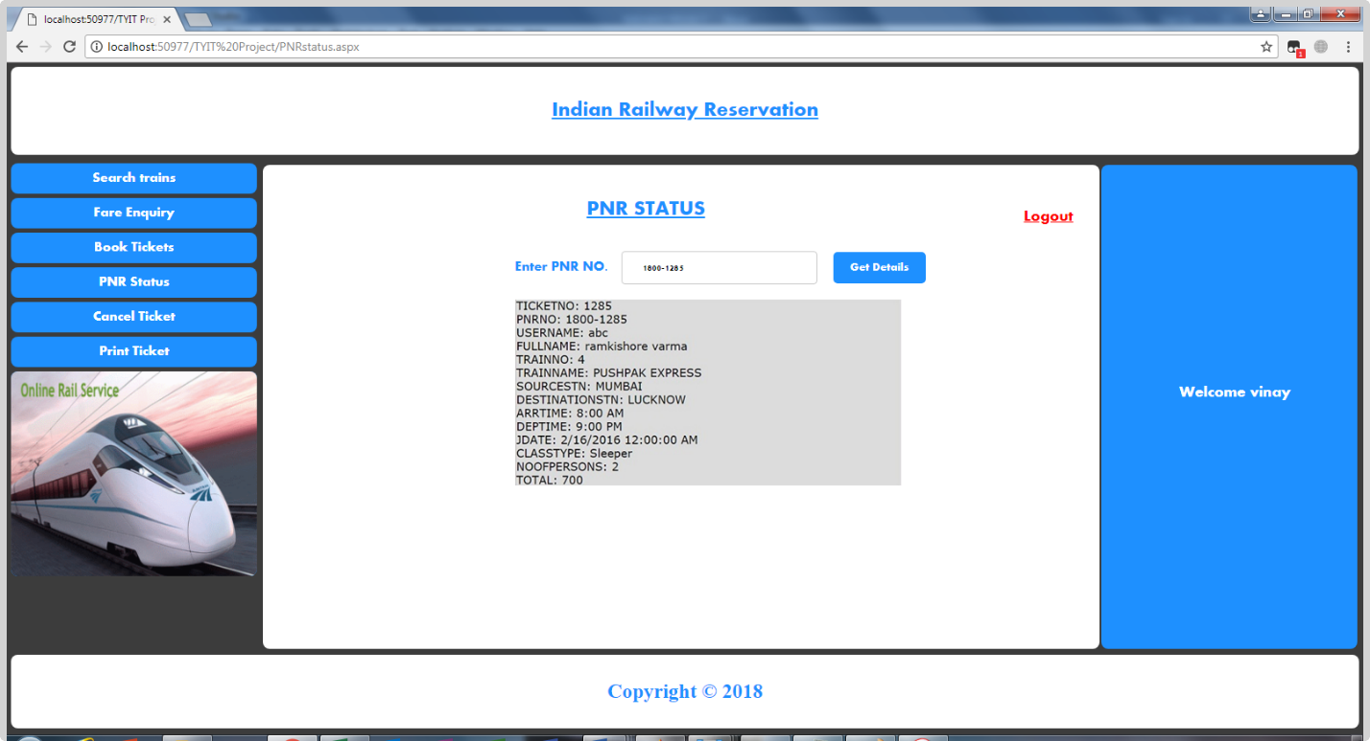

**PrintTicket.aspx**

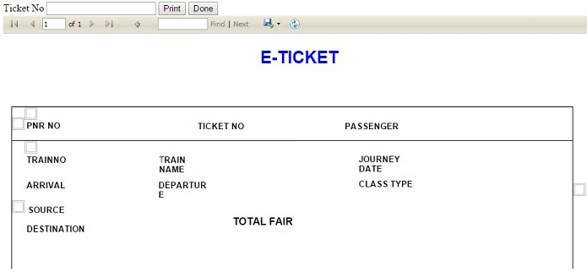

**Source code:**

<%@ Page Language="C#" AutoEventWireup="true" CodeFile="PrintTicket.aspx.cs" Inherits="PrintTicket" %>

<%@ Register assembly="Microsoft.ReportViewer.WebForms, Version=10.0.0.0, Culture=neutral, PublicKeyToken=b03f5f7f11d50a3a" namespace="Microsoft.Reporting.WebForms" tagprefix="rsweb" %>

<!DOCTYPE html PUBLIC "-//W3C//DTD XHTML 1.0 Transitional//EN" "http://www.w3.org/TR/xhtml1/DTD/xhtml1-transitional.dtd">

<html xmlns="http://www.w3.org/1999/xhtml">

<head runat="server">

<title></title>

</head>

<body>

<form id="form1" runat="server">

<div>

<asp:Label ID="Label1" runat="server" Text="Ticket No."></asp:Label>

&nbsp;&nbsp;&nbsp;

<asp:TextBox ID="TextBox1" runat="server"></asp:TextBox>

&nbsp;&nbsp;&nbsp;

<asp:Button ID="Button1" runat="server" Text="Print" />

&nbsp;&nbsp;&nbsp;

<asp:Button ID="Button2" runat="server" Text="Done" />

<br />

<asp:ScriptManager ID="ScriptManager1" runat="server">

</asp:ScriptManager>

<rsweb:ReportViewerID="ReportViewer1"runat="server"Font-Names="Verdana"

Font-Size="8pt"InteractiveDeviceInfos="(Collection)"

WaitMessageFont-Names="Verdana"WaitMessageFont-Size="14pt"Width="100%">

<LocalReportReportPath="Report.rdlc">

<DataSources>

<rsweb:ReportDataSourceDataSourceId="ObjectDataSource2"Name="DataSet1"/>

</DataSources>

</LocalReport>

</rsweb:ReportViewer>

<asp:ObjectDataSourceID="ObjectDataSource2"runat="server"

DeleteMethod="Delete"InsertMethod="Insert"

OldValuesParameterFormatString="original_{0}"SelectMethod="GetData"

TypeName="DataSet2TableAdapters.TICKETTableAdapter"UpdateMethod="Update">

<DeleteParameters>

<asp:ParameterName="Original_TICKETNO"Type="Int32"/>

</DeleteParameters>

<InsertParameters>

<asp:ParameterName="PNRNO"Type="String"/>

<asp:ParameterName="FULLNAME"Type="String"/>

<asp:ParameterName="TRAINNO"Type="Int32"/>

<asp:ParameterName="TRAINNAME"Type="String"/>

<asp:ParameterName="SOURCESTN"Type="String"/>

<asp:ParameterName="DESTINATIONSTN"Type="String"/>

<asp:ParameterName="ARRTIME"Type="String"/>

<asp:ParameterName="DEPTIME"Type="String"/>

<asp:ParameterName="JDATE"Type="DateTime"/>

<asp:ParameterName="CLASSTYPE"Type="String"/>

<asp:ParameterName="NOOFPERSONS"Type="Int32"/>

<asp:ParameterName="TOTAL"Type="Int32"/>

</InsertParameters>

<SelectParameters>

<asp:ControlParameterControlID="TextBox1"DefaultValue="1"Name="TNO"

PropertyName="Text"Type="Int32"/>

</SelectParameters>

<UpdateParameters>

<asp:ParameterName="PNRNO"Type="String"/>

<asp:ParameterName="FULLNAME"Type="String"/>

<asp:ParameterName="TRAINNO"Type="Int32"/>

<asp:ParameterName="TRAINNAME"Type="String"/>

<asp:ParameterName="SOURCESTN"Type="String"/>

<asp:ParameterName="DESTINATIONSTN"Type="String"/>

<asp:ParameterName="ARRTIME"Type="String"/>

<asp:ParameterName="DEPTIME"Type="String"/>

<asp:ParameterName="JDATE"Type="DateTime"/>

<asp:ParameterName="CLASSTYPE"Type="String"/>

<asp:ParameterName="NOOFPERSONS"Type="Int32"/>

<asp:ParameterName="TOTAL"Type="Int32"/>

<asp:ParameterName="Original_TICKETNO"Type="Int32"/>

</UpdateParameters>

</asp:ObjectDataSource>

<asp:ObjectDataSourceID="ObjectDataSource1"runat="server"

SelectMethod="GetData"TypeName="DataSet2TableAdapters.TICKETTableAdapter">

</asp:ObjectDataSource>

</div>

</form>

</body>

</html>

**FUTURE OF SCOPE :**

Reservation Clerk is a person to create and Cancel Reservation by entering Login Password. Manager is a person who updates the Train Information by entering his own Password. The system can handle only reservation and train details efficiently and it doesn’t contain other details about the railway administration. The main purpose of this system is

* Creating reservation
* Cancel reservation
* View reservation status
* View train schedule
* Generating reports
* Update train schedule
* Update reservation details

The Seats of Reservation cannot be more than the seats of Train at that date. This is a constraint that has to be followed by the Clerk when he creates the Reservation. For that purpose he wants to check the seats remaining present in the Train. The scope of this system in creating Reservation is that, from any Railway Station we can Create Reservation, which is updated automatically in all the stations. Hence, there is no confusion to the Reservation Clerk in all the stations to create the Reservation.

Clerks present at different stations can access the global database and the clerks can easily understand the remaining reservation seats. It provides the ability to create reservation from different places for a train. The system is so secured and clerk and manager utilize it. Nobody can able to access the system without his or her permission because of providing login facility to the system. The password is in the form of cipher text by using cryptography technology, so it cannot be hacked by any person. The global database can passes through network in order to utilized by managers or clerks at different places. So, we want to provide network security because of the data not hacked by the other persons when it is going through network cables. This network security is provided by the cryptography technology.

**Bibliography :**

[www.stackoverflow.com](http://www.stackoverflow.com)

[www.tutorialpoint.com](http://www.tutorialpoint.com)

[www.dothat.com](http://www.dothat.com)

[www.wikipedia.com](http://www.wikipedia.com)

[www.bOtskOOl.com](http://www.bOtskOOl.com)